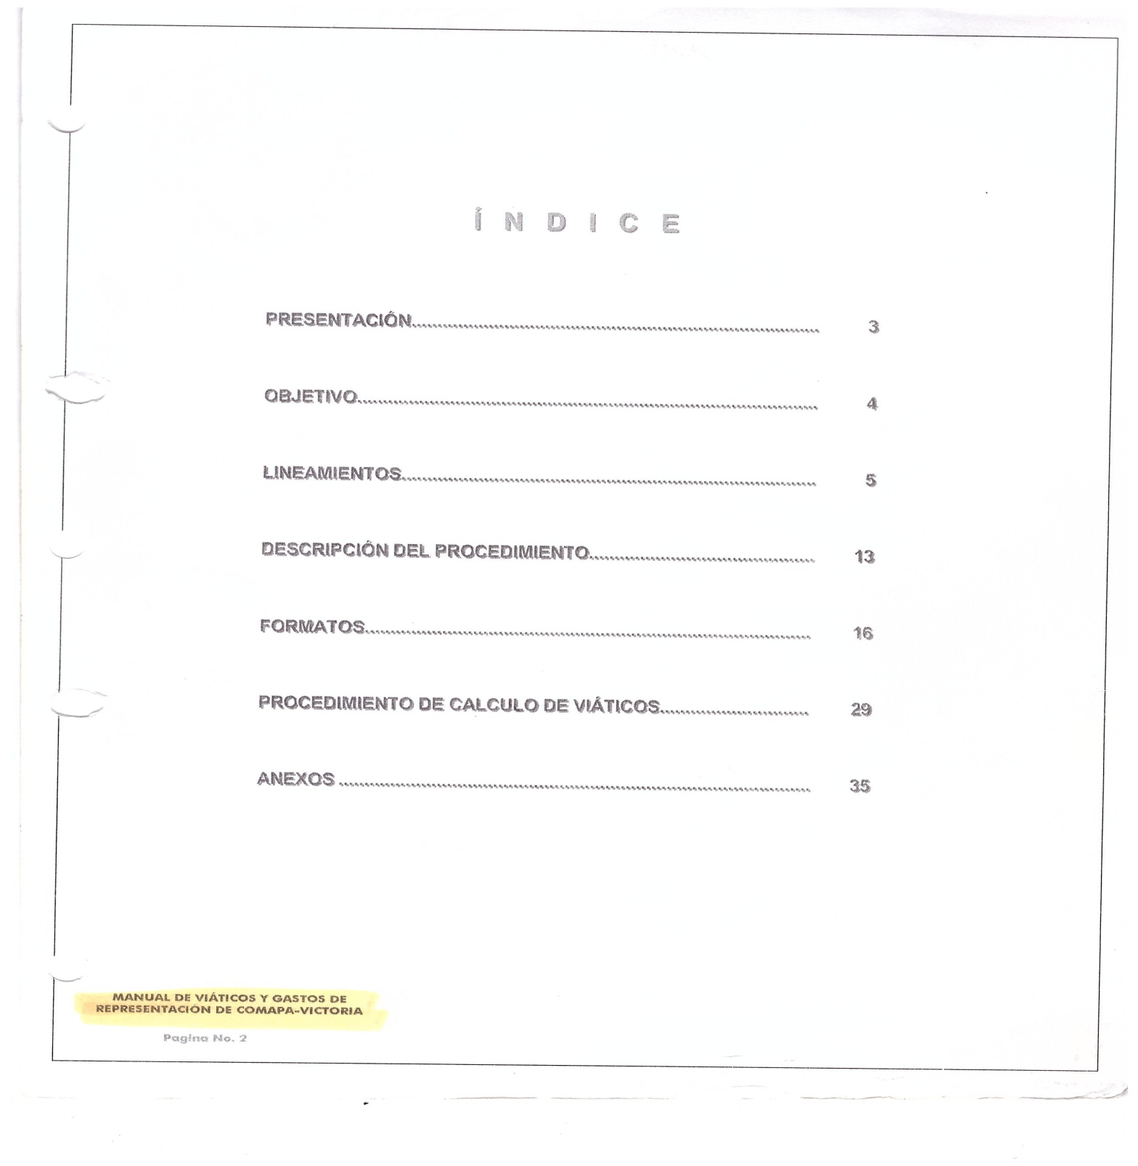

________________________ ________________________________ _____________________________
ING. ELISEO GARCIA LEAL C.P. SERGIO MARTINEZ VILLARREAL C.P. LAURA ARRIETA HERNANDEZ
GERENTE GENERAL GERENTE ADMINISTRATIVO CONTROL ESTADISTICO

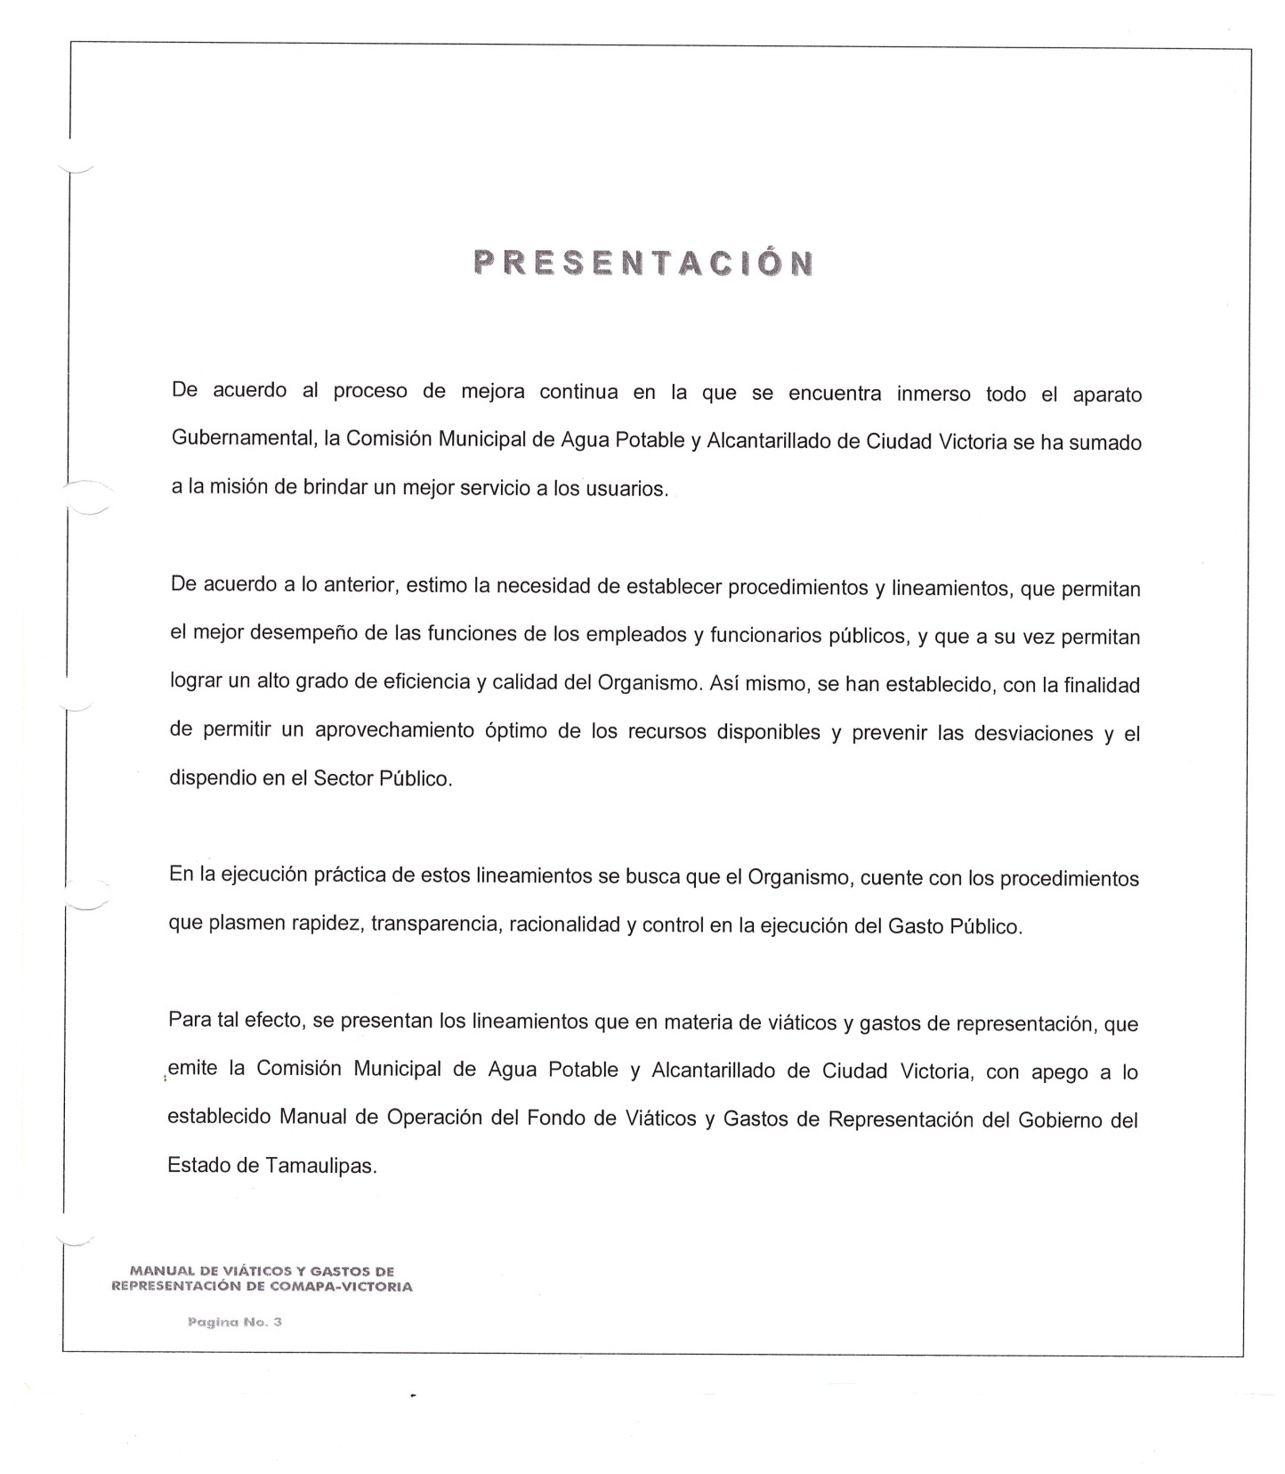

________________________ ________________________________ _____________________________
ING. ELISEO GARCIA LEAL C.P. SERGIO MARTINEZ VILLARREAL C.P. LAURA ARRIETA HERNANDEZ
GERENTE GENERAL GERENTE ADMINISTRATIVO CONTROL ESTADISTICO

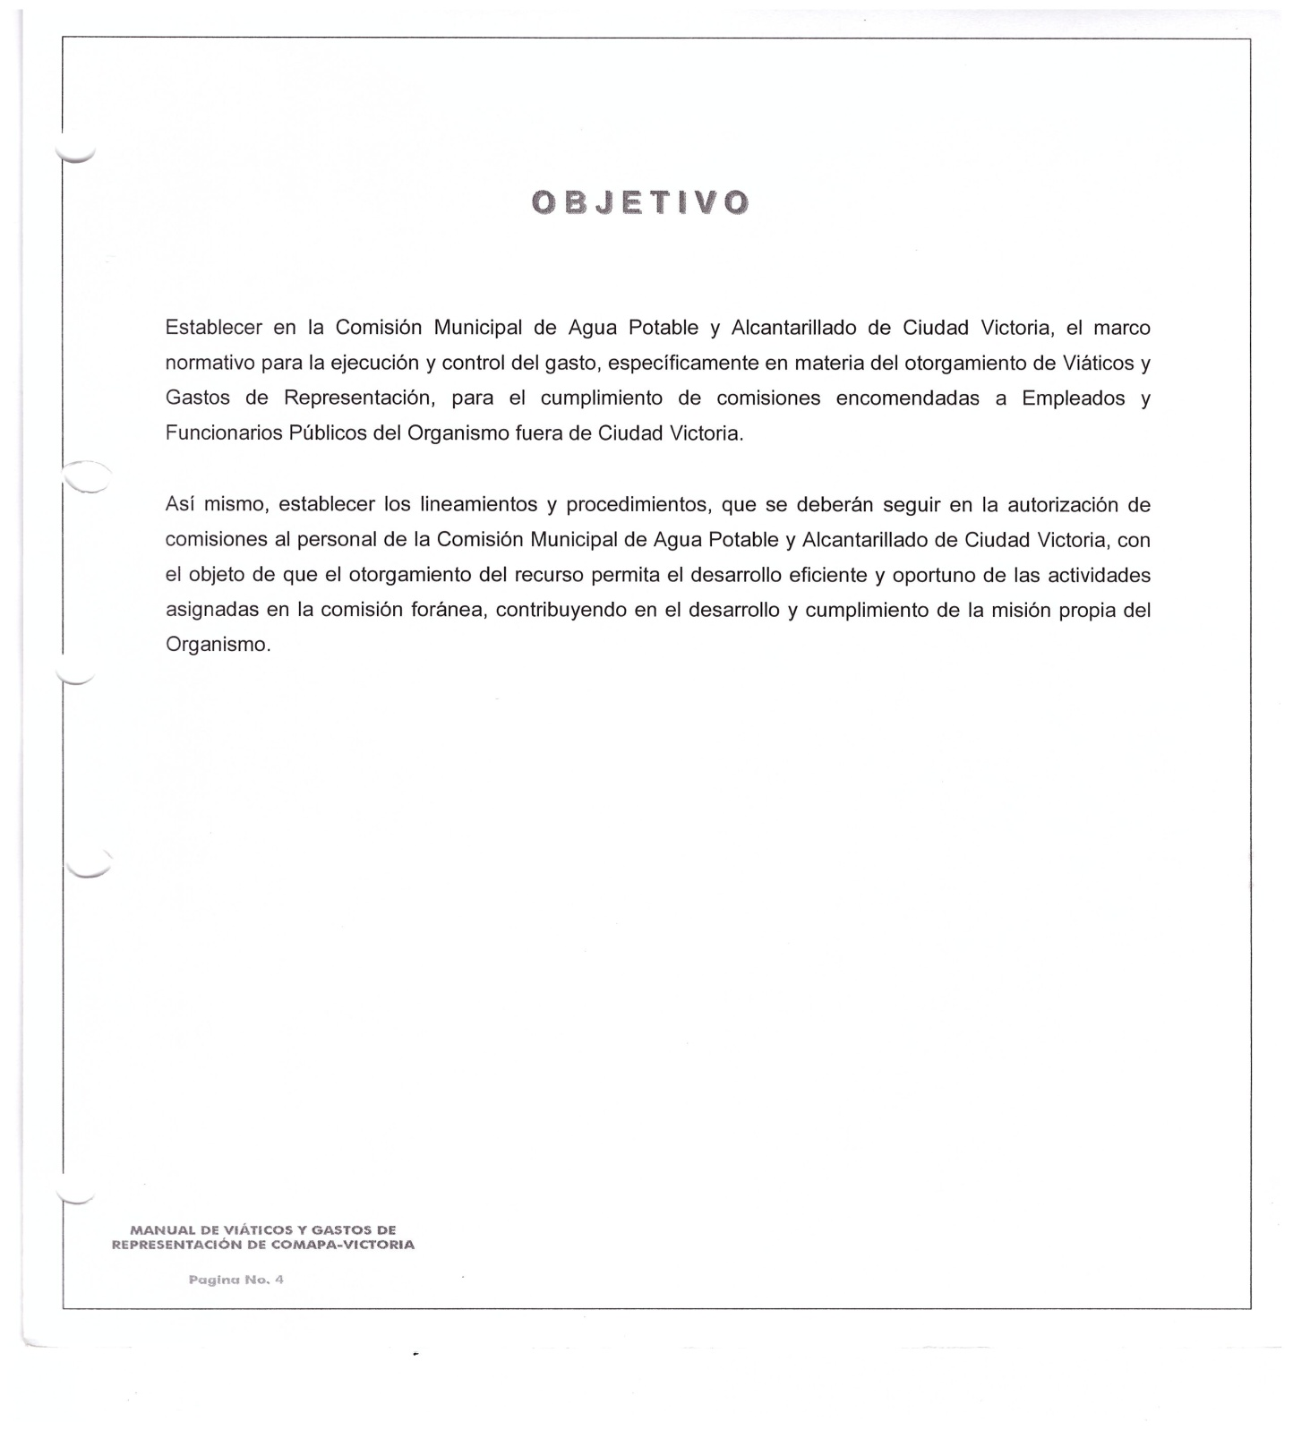

________________________ ________________________________ _____________________________
ING. ELISEO GARCIA LEAL C.P. SERGIO MARTINEZ VILLARREAL C.P. LAURA ARRIETA HERNANDEZ
GERENTE GENERAL GERENTE ADMINISTRATIVO CONTROL ESTADISTICO

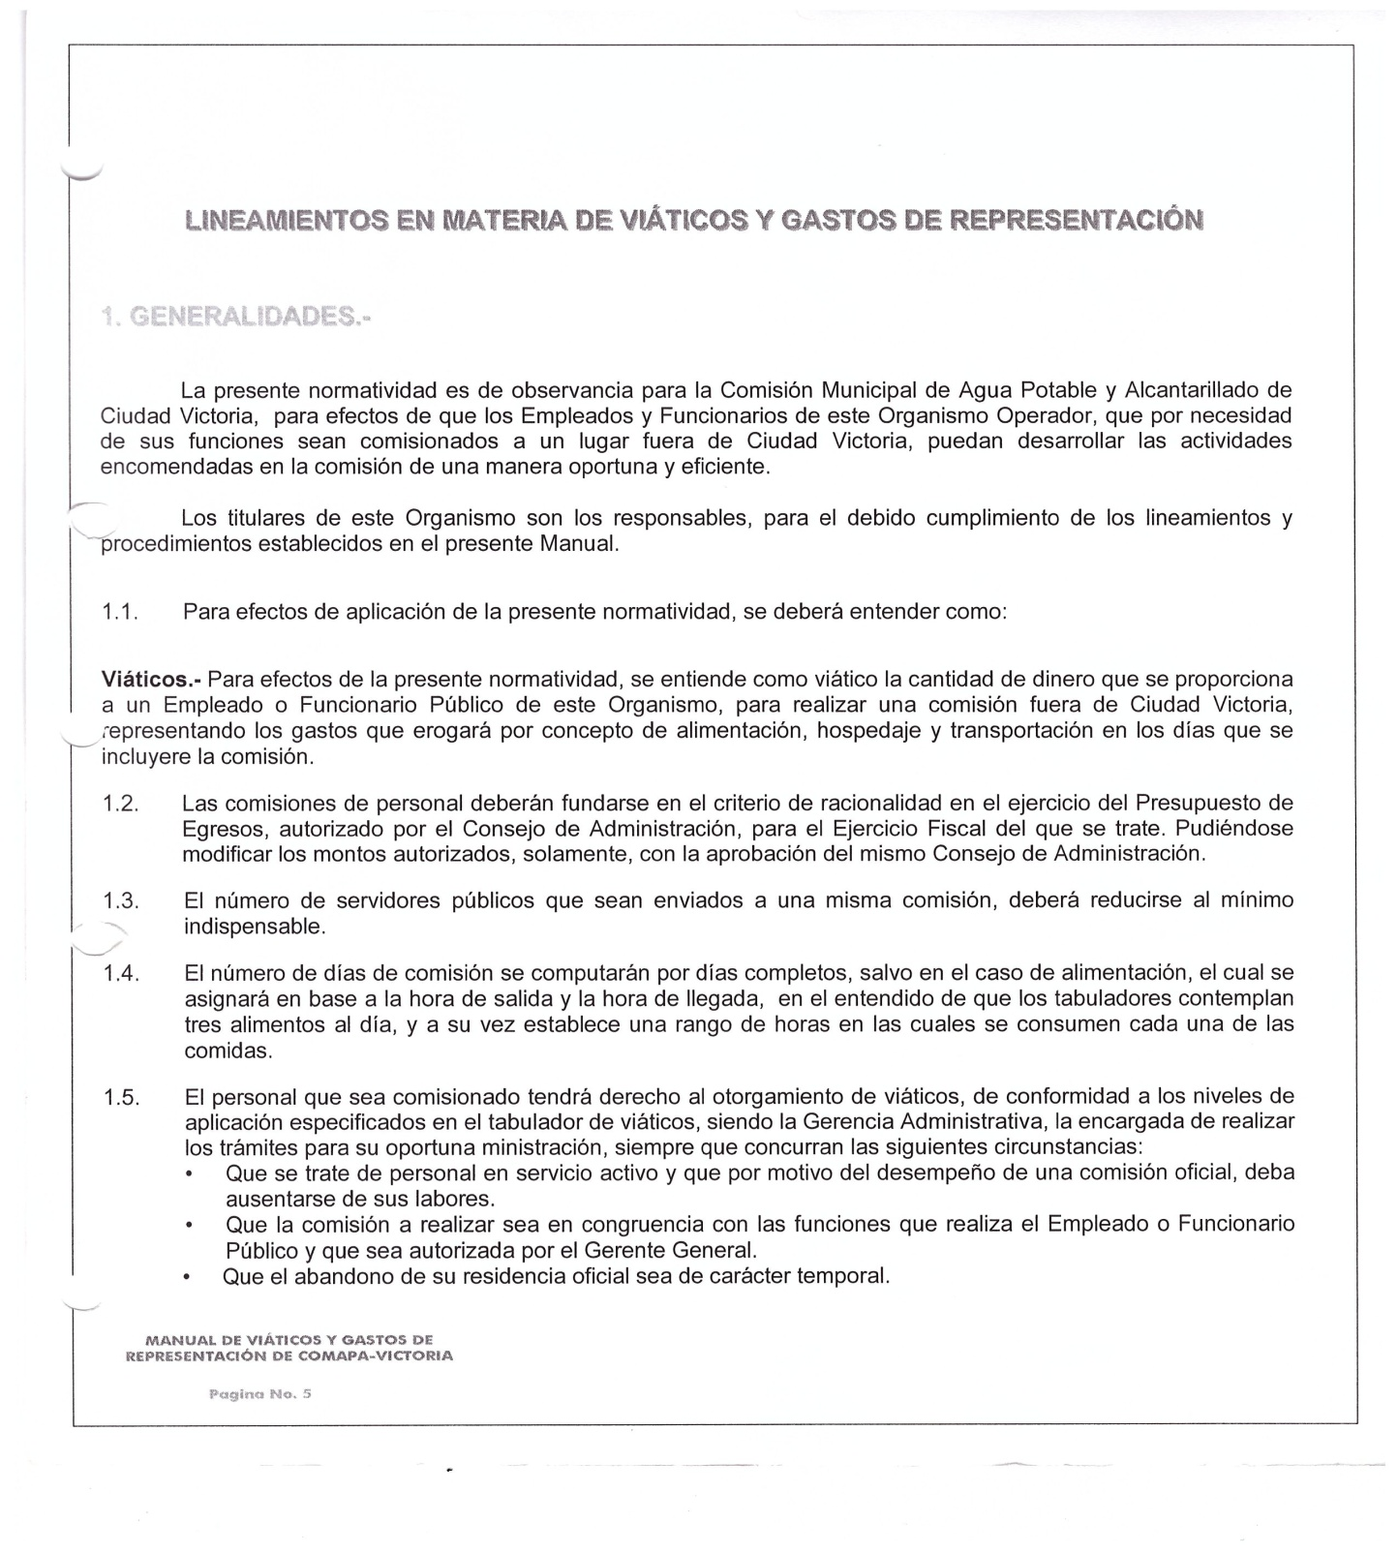

________________________ ________________________________ _____________________________
ING. ELISEO GARCIA LEAL C.P. SERGIO MARTINEZ VILLARREAL C.P. LAURA ARRIETA HERNANDEZ
GERENTE GENERAL GERENTE ADMINISTRATIVO CONTROL ESTADISTICO

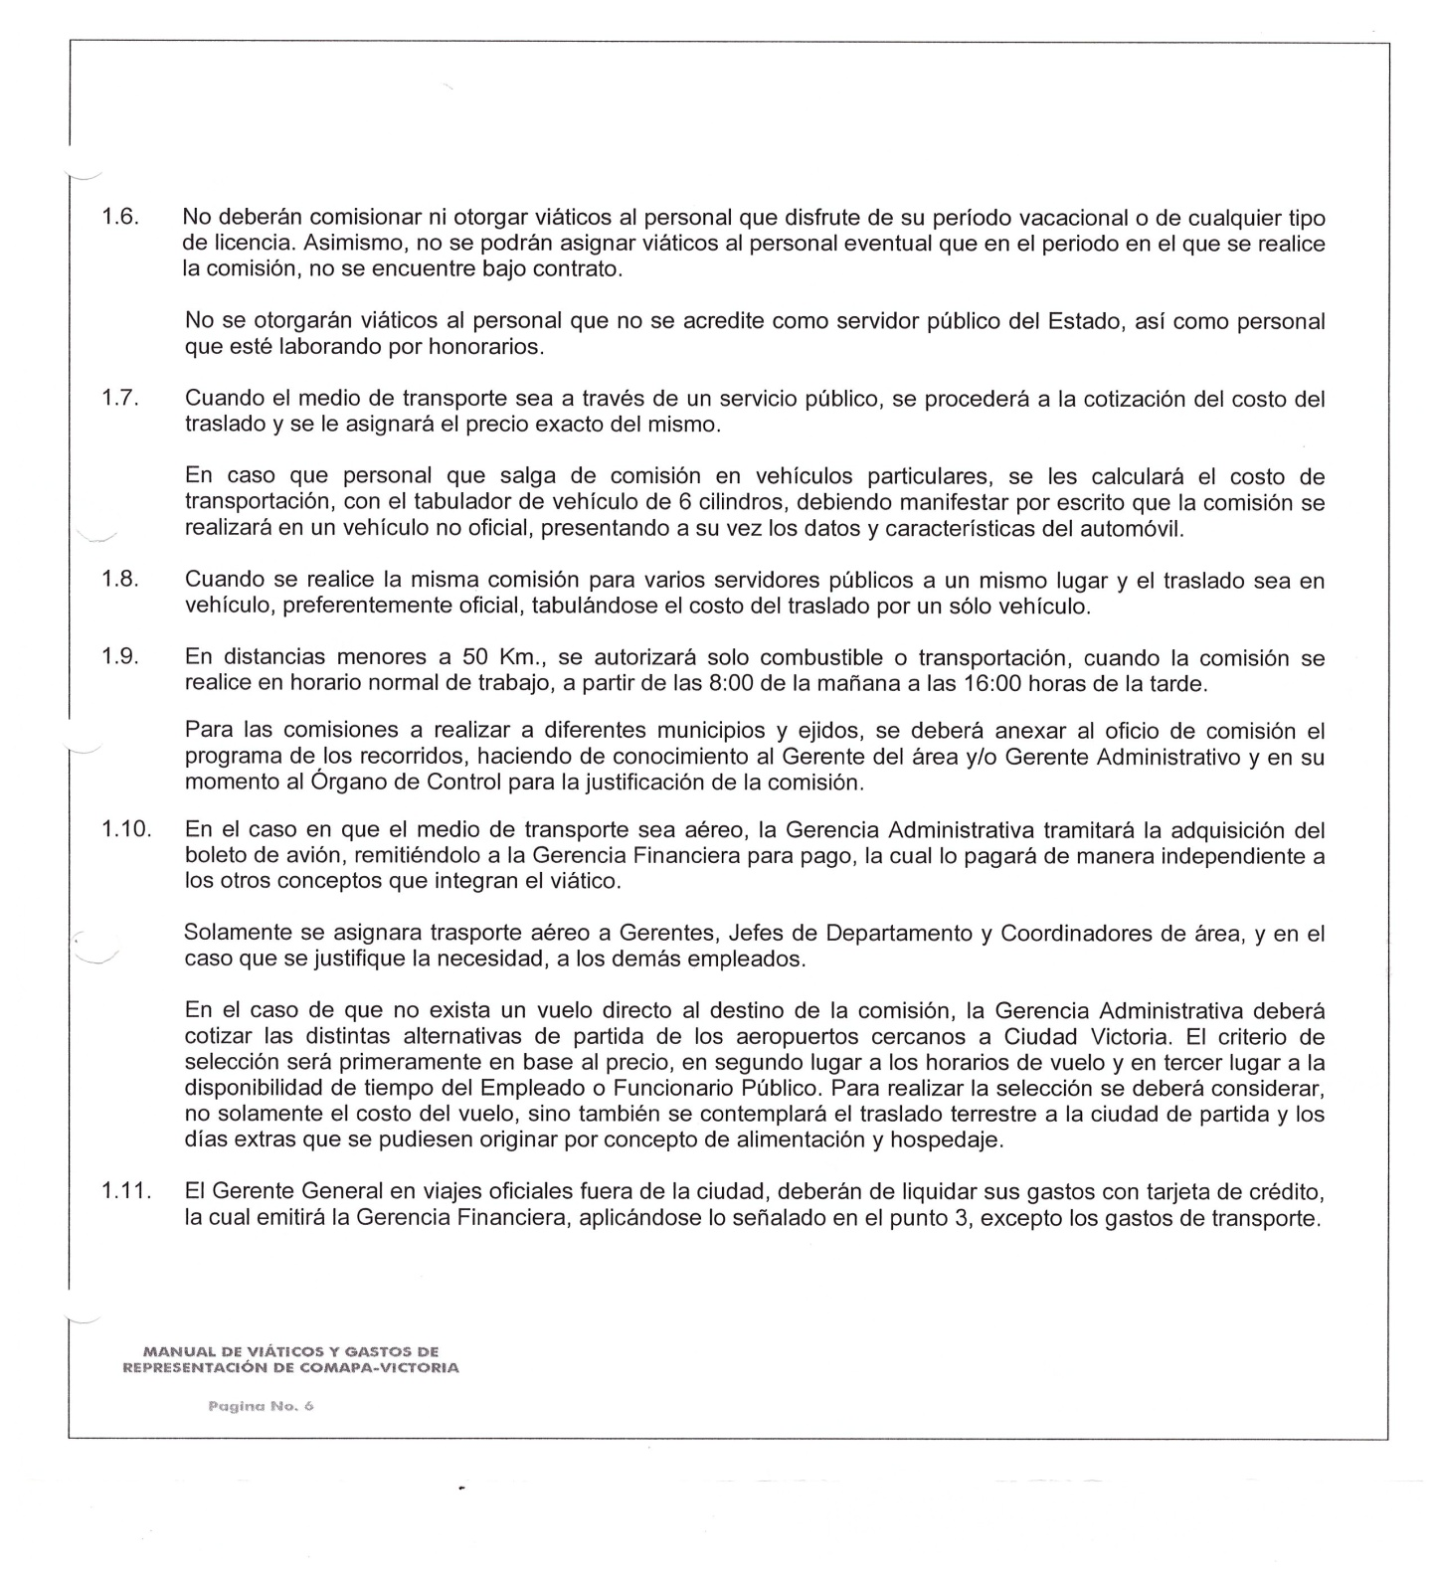

________________________ ________________________________ _____________________________
ING. ELISEO GARCIA LEAL C.P. SERGIO MARTINEZ VILLARREAL C.P. LAURA ARRIETA HERNANDEZ
GERENTE GENERAL GERENTE ADMINISTRATIVO CONTROL ESTADISTICO

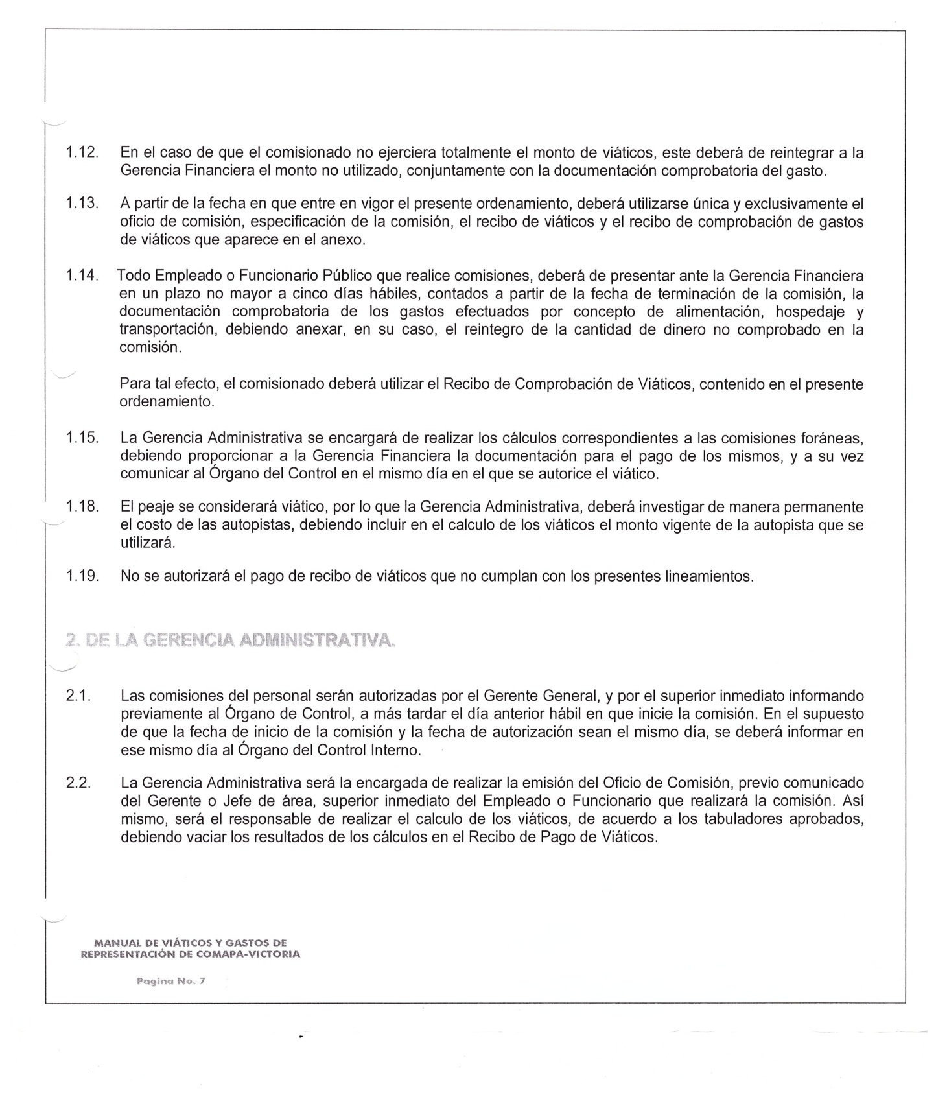

________________________ ________________________________ _____________________________
ING. ELISEO GARCIA LEAL C.P. SERGIO MARTINEZ VILLARREAL C.P. LAURA ARRIETA HERNANDEZ
GERENTE GENERAL GERENTE ADMINISTRATIVO CONTROL ESTADISTICO

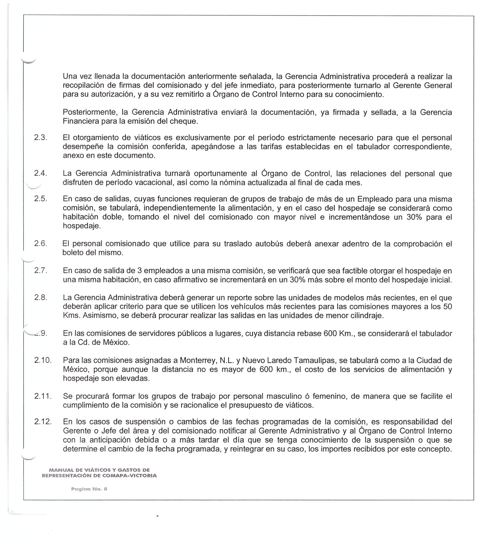

________________________ ________________________________ _____________________________
ING. ELISEO GARCIA LEAL C.P. SERGIO MARTINEZ VILLARREAL C.P. LAURA ARRIETA HERNANDEZ
GERENTE GENERAL GERENTE ADMINISTRATIVO CONTROL ESTADISTICO

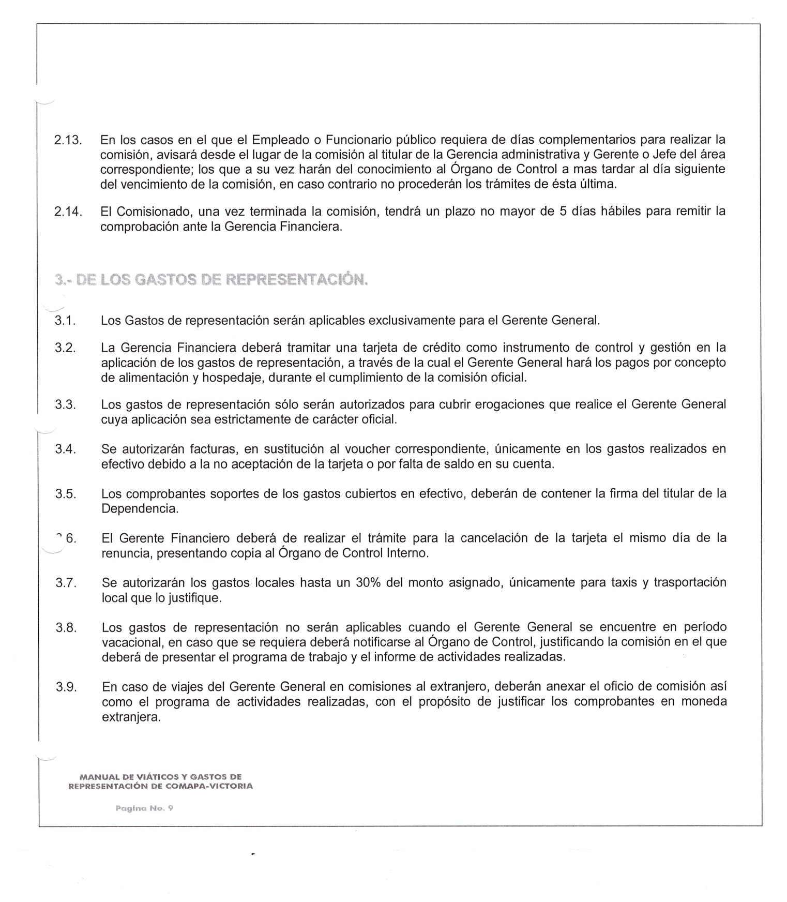

________________________ ________________________________ _____________________________
ING. ELISEO GARCIA LEAL C.P. SERGIO MARTINEZ VILLARREAL C.P. LAURA ARRIETA HERNANDEZ
GERENTE GENERAL GERENTE ADMINISTRATIVO CONTROL ESTADISTICO

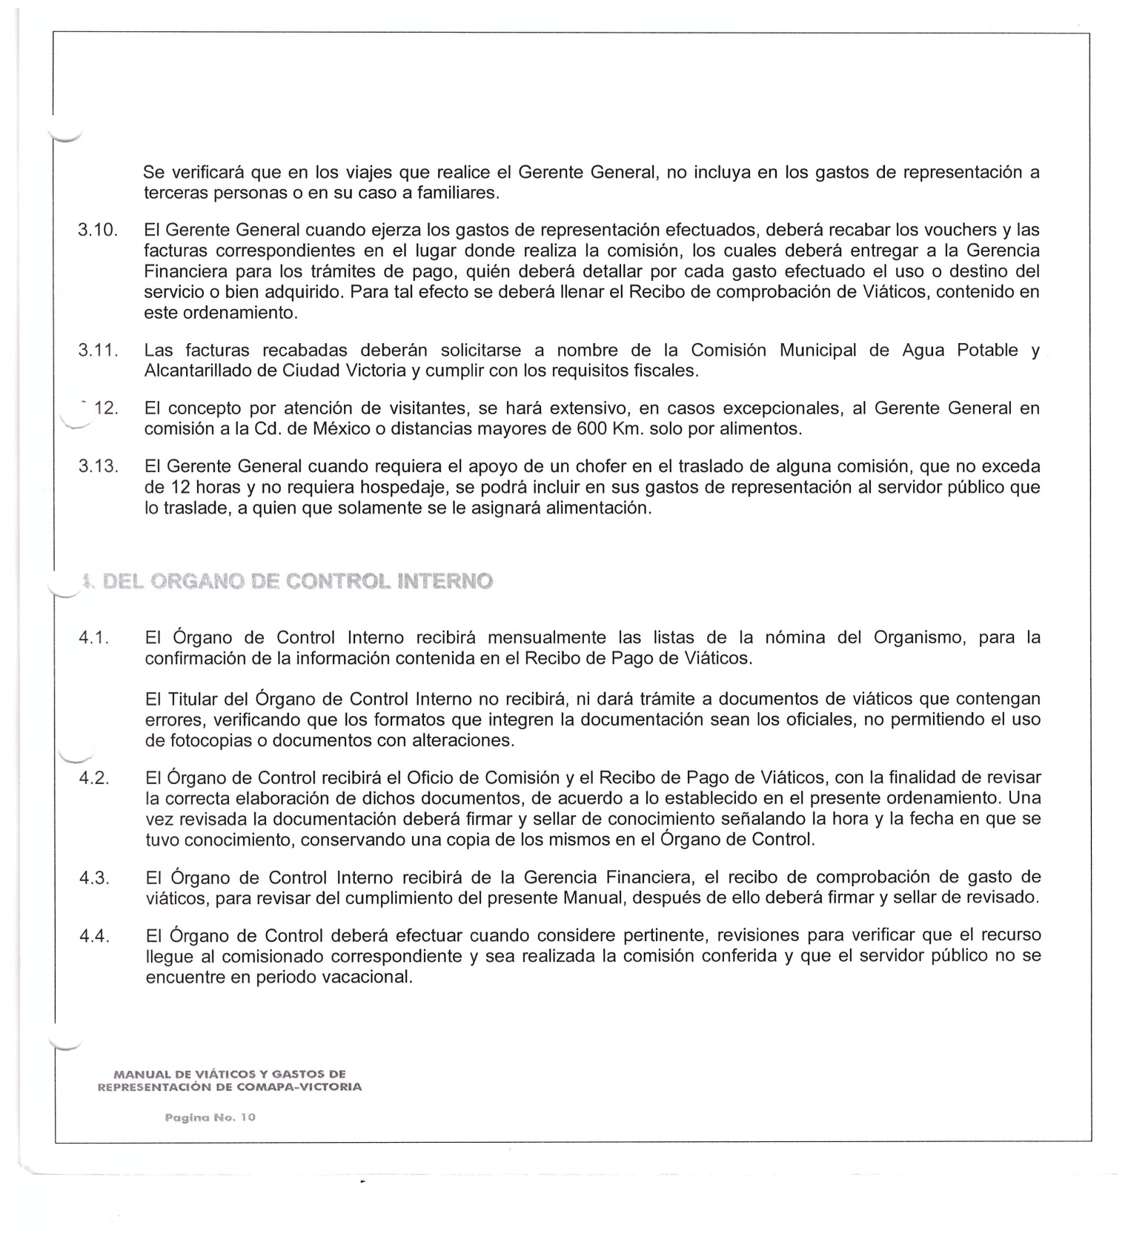

________________________ ________________________________ _____________________________
ING. ELISEO GARCIA LEAL C.P. SERGIO MARTINEZ VILLARREAL C.P. LAURA ARRIETA HERNANDEZ
GERENTE GENERAL GERENTE ADMINISTRATIVO CONTROL ESTADISTICO

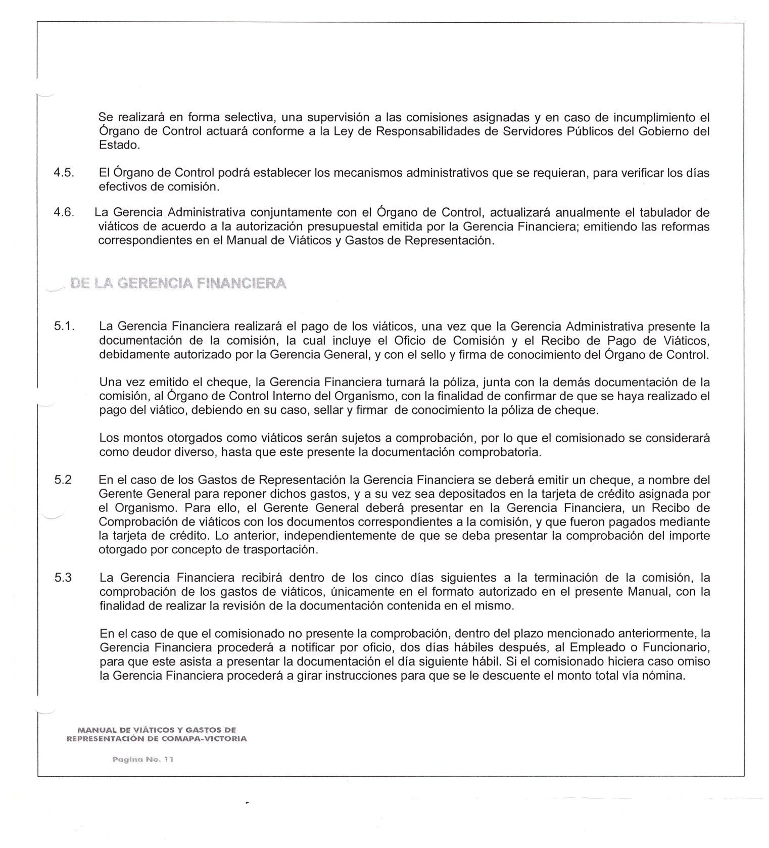

________________________ ________________________________ _____________________________
ING. ELISEO GARCIA LEAL C.P. SERGIO MARTINEZ VILLARREAL C.P. LAURA ARRIETA HERNANDEZ
GERENTE GENERAL GERENTE ADMINISTRATIVO CONTROL ESTADISTICO

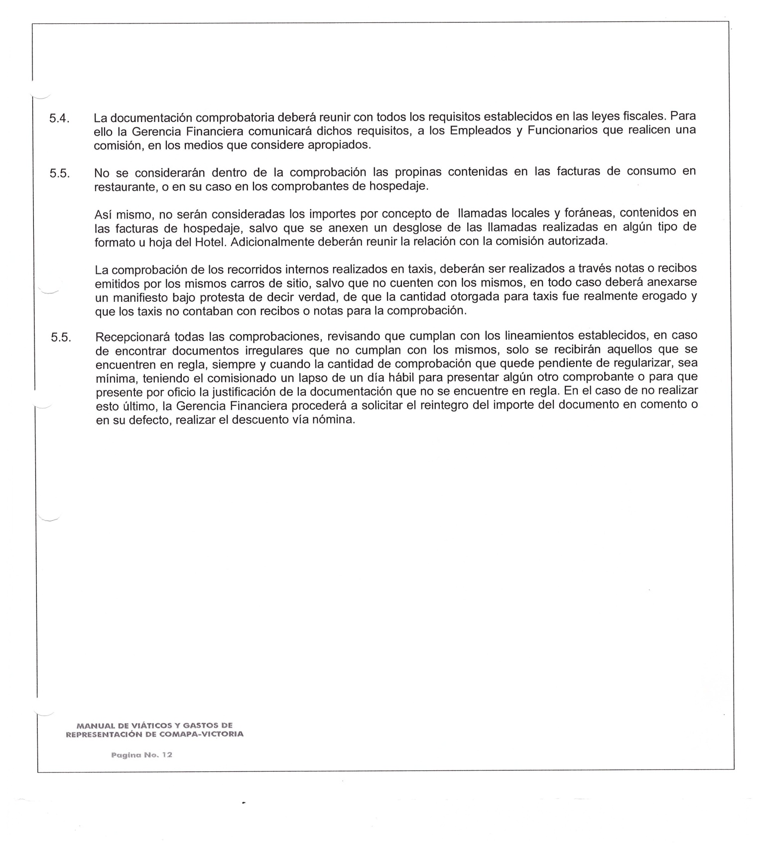

________________________ ________________________________ _____________________________
ING. ELISEO GARCIA LEAL C.P. SERGIO MARTINEZ VILLARREAL C.P. LAURA ARRIETA HERNANDEZ
GERENTE GENERAL GERENTE ADMINISTRATIVO CONTROL ESTADISTICO

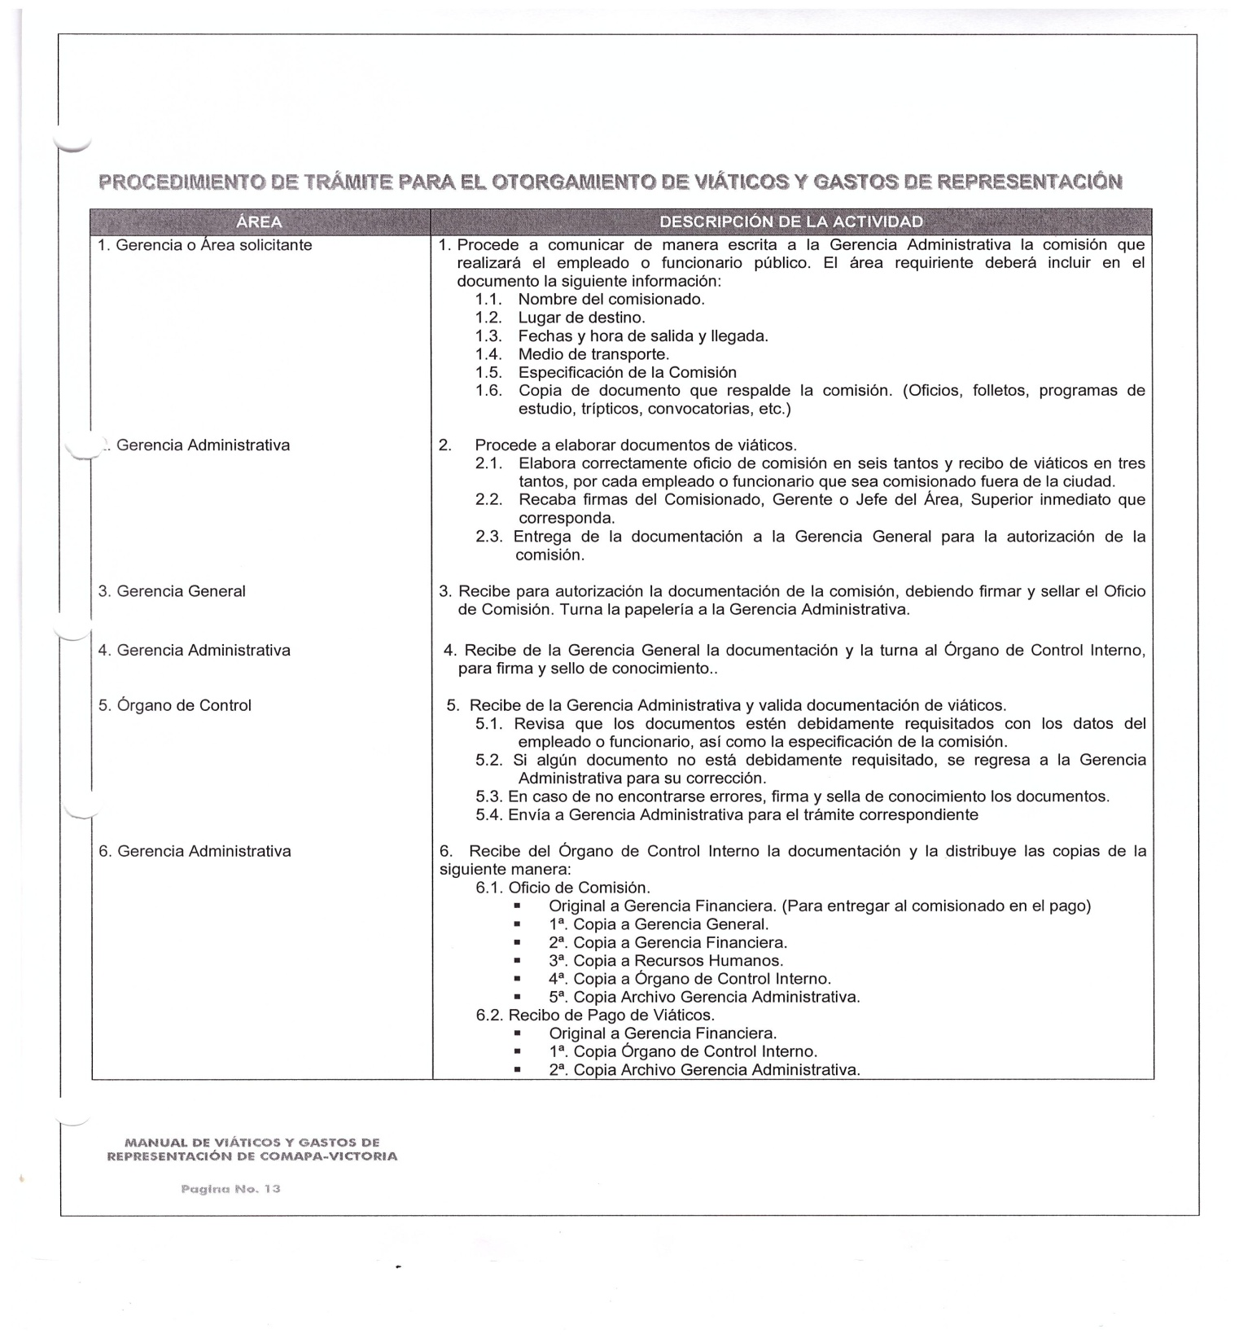

________________________ ________________________________ _____________________________
ING. ELISEO GARCIA LEAL C.P. SERGIO MARTINEZ VILLARREAL C.P. LAURA ARRIETA HERNANDEZ
GERENTE GENERAL GERENTE ADMINISTRATIVO CONTROL ESTADISTICO

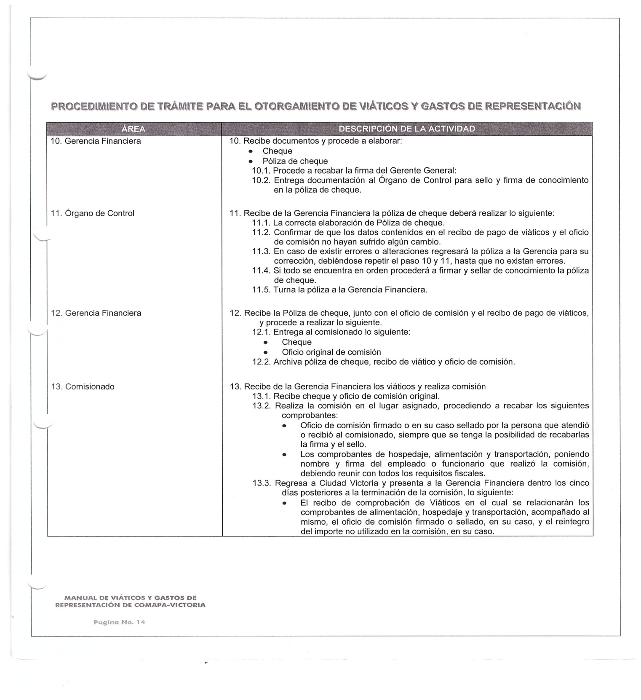

________________________ ________________________________ _____________________________
ING. ELISEO GARCIA LEAL C.P. SERGIO MARTINEZ VILLARREAL C.P. LAURA ARRIETA HERNANDEZ
GERENTE GENERAL GERENTE ADMINISTRATIVO CONTROL ESTADISTICO

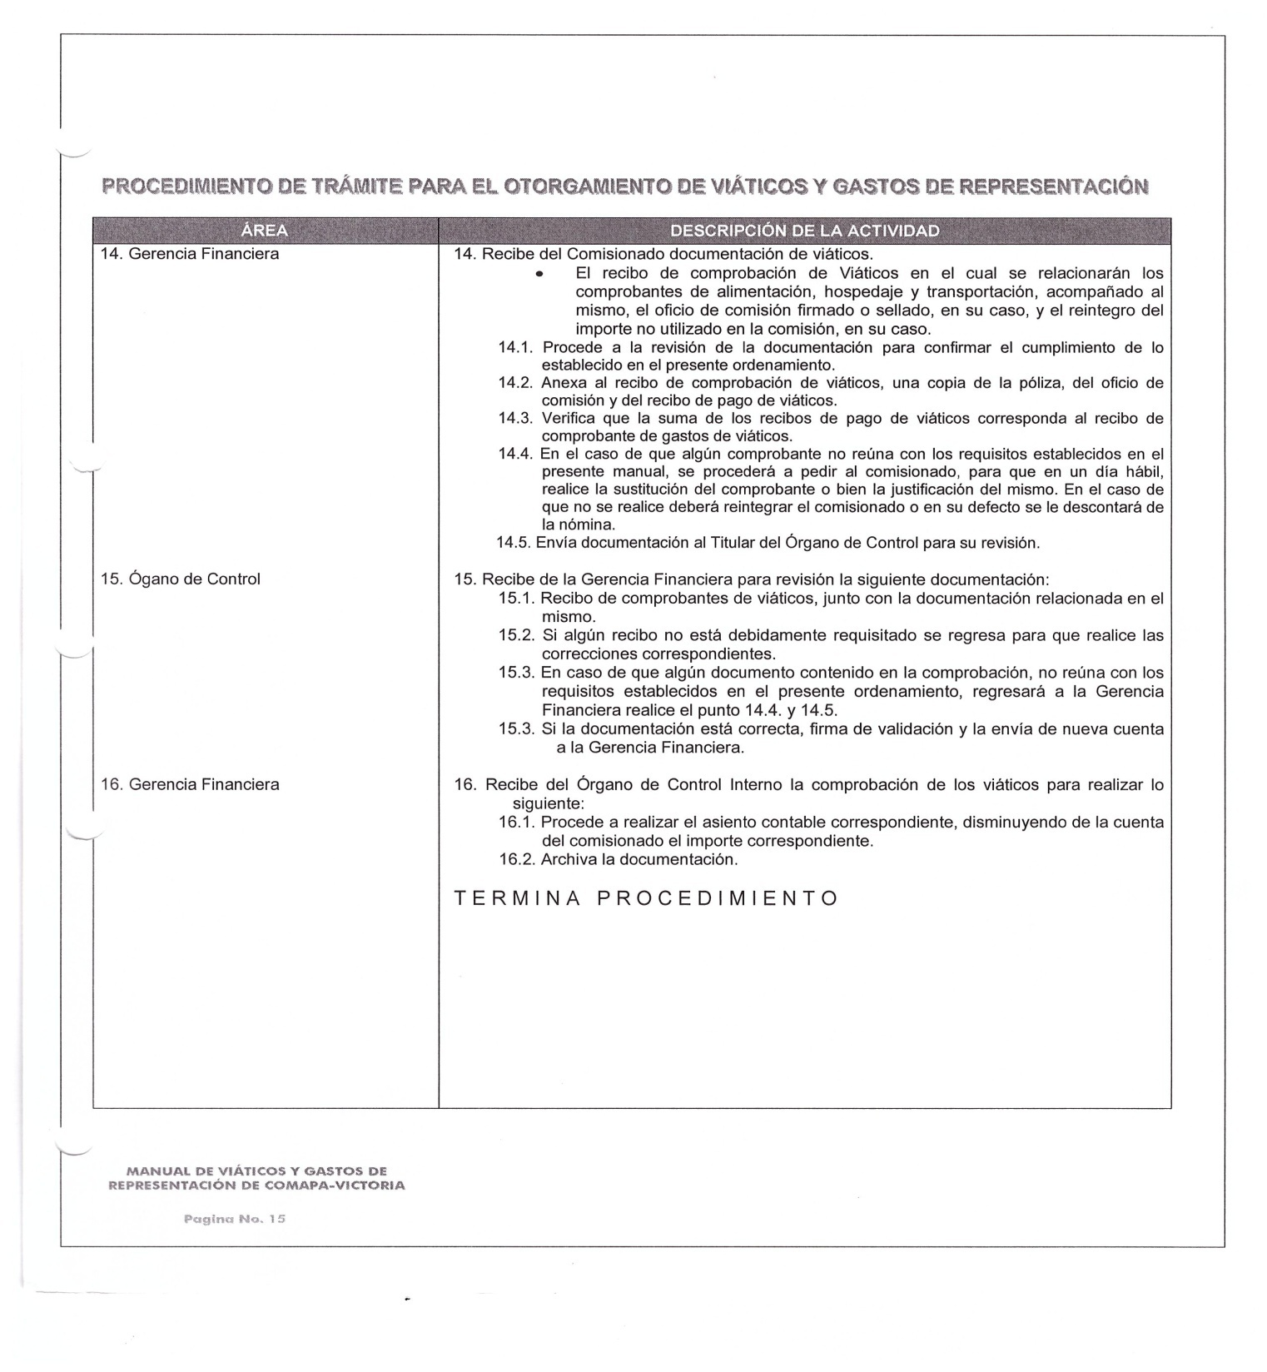

________________________ ________________________________ _____________________________
ING. ELISEO GARCIA LEAL C.P. SERGIO MARTINEZ VILLARREAL C.P. LAURA ARRIETA HERNANDEZ
GERENTE GENERAL GERENTE ADMINISTRATIVO CONTROL ESTADISTICO

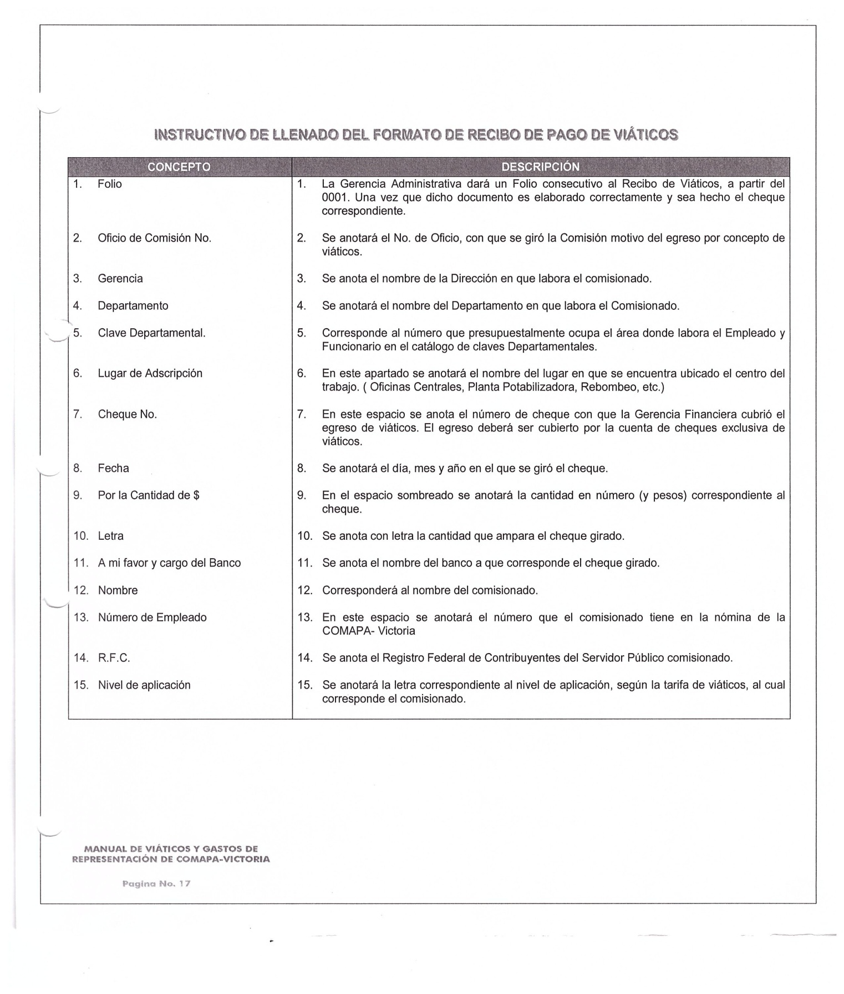

________________________ ________________________________ _____________________________
ING. ELISEO GARCIA LEAL C.P. SERGIO MARTINEZ VILLARREAL C.P. LAURA ARRIETA HERNANDEZ
GERENTE GENERAL GERENTE ADMINISTRATIVO CONTROL ESTADISTICO

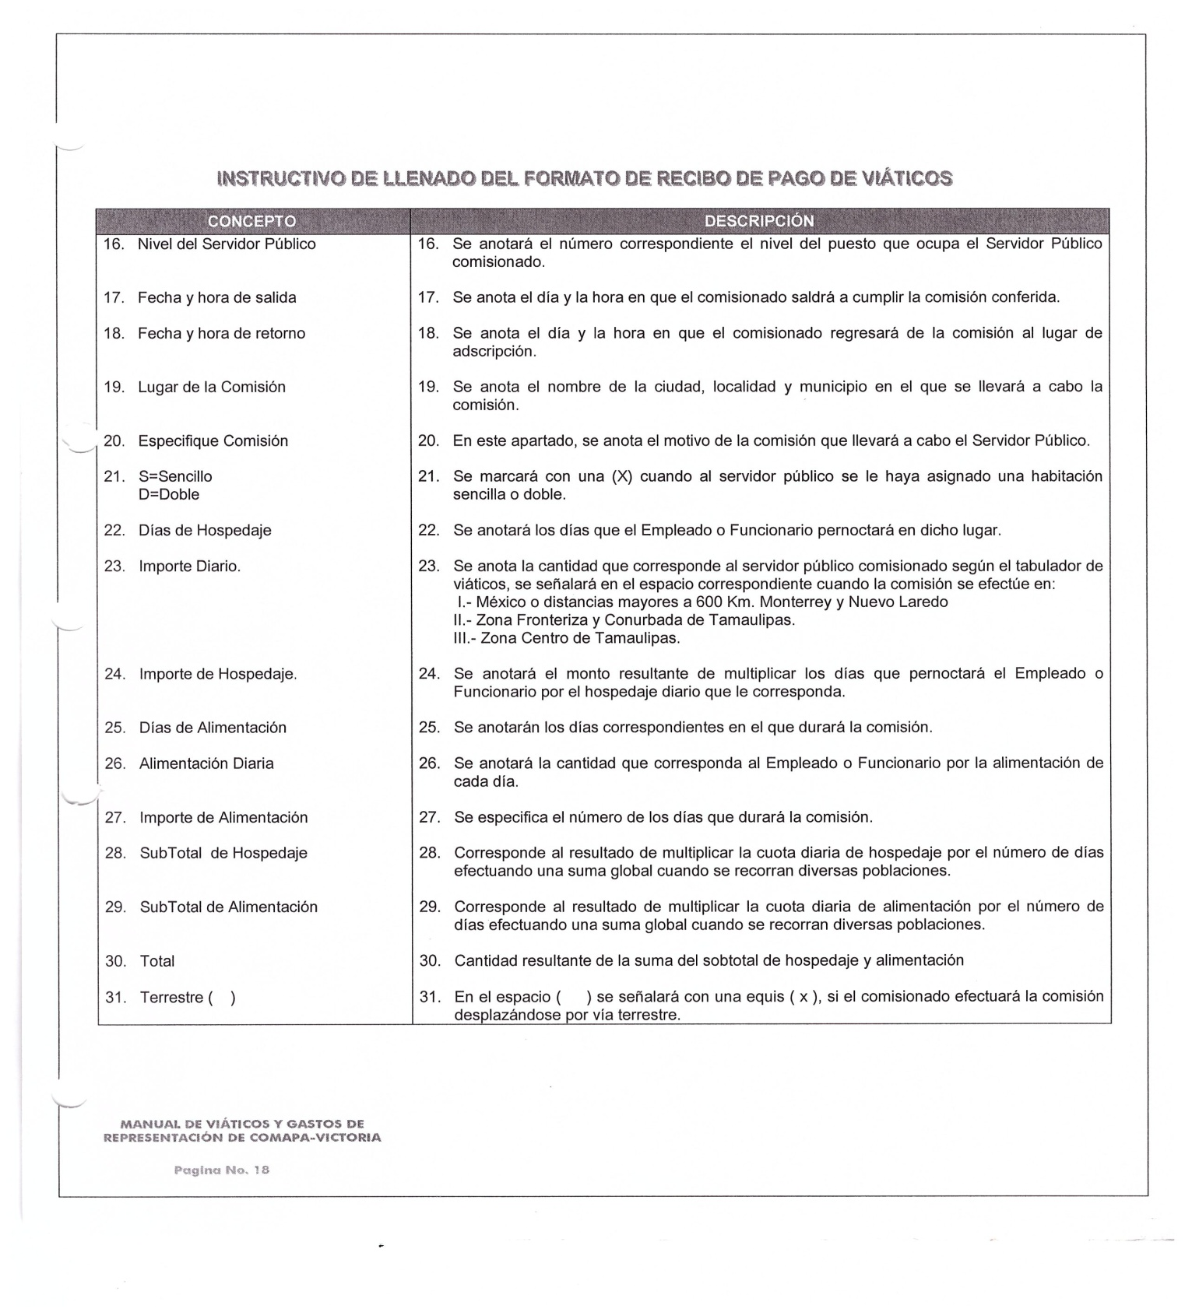

________________________ ________________________________ _____________________________
ING. ELISEO GARCIA LEAL C.P. SERGIO MARTINEZ VILLARREAL C.P. LAURA ARRIETA HERNANDEZ
GERENTE GENERAL GERENTE ADMINISTRATIVO CONTROL ESTADISTICO

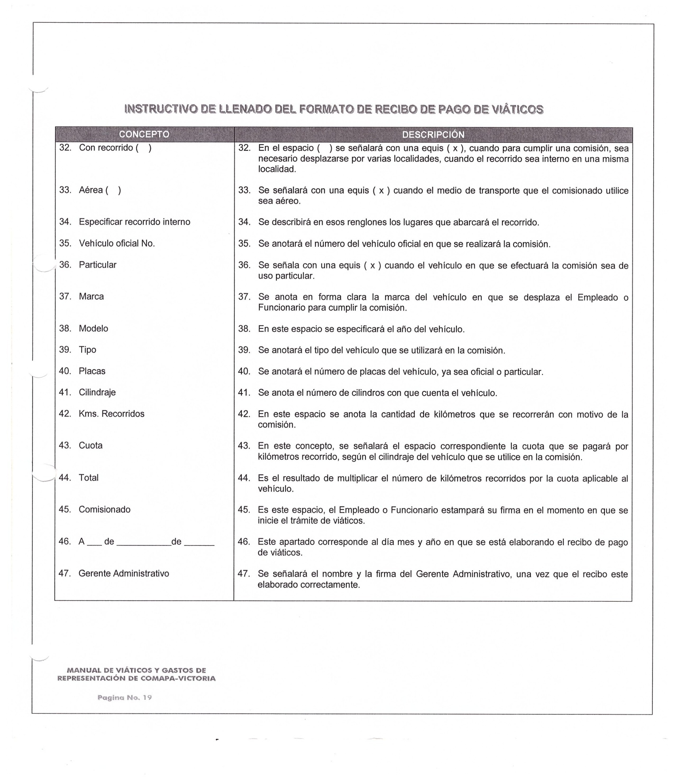

________________________ ________________________________ _____________________________
ING. ELISEO GARCIA LEAL C.P. SERGIO MARTINEZ VILLARREAL C.P. LAURA ARRIETA HERNANDEZ
GERENTE GENERAL GERENTE ADMINISTRATIVO CONTROL ESTADISTICO

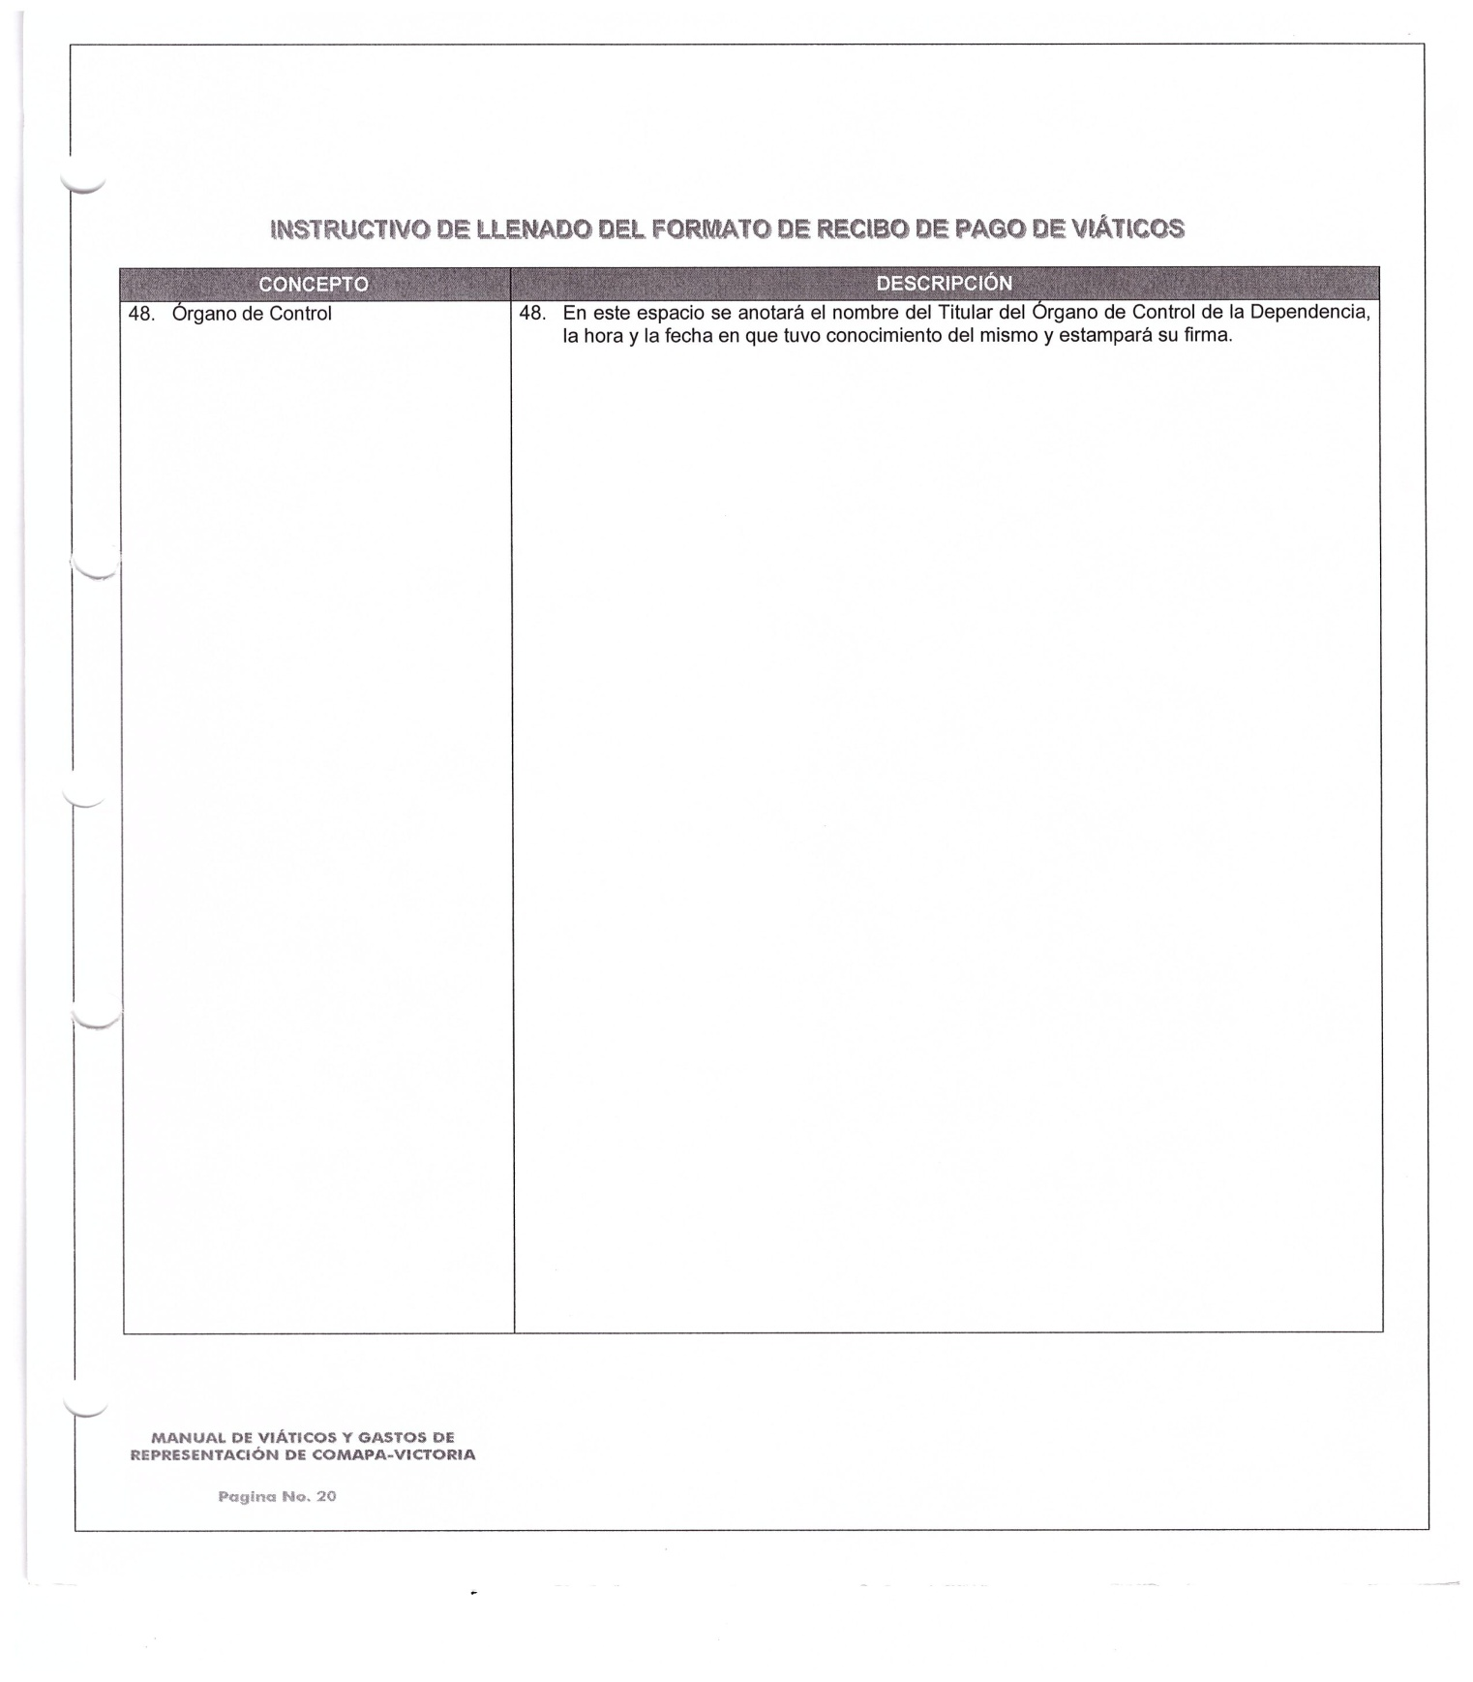

________________________ ________________________________ _____________________________
ING. ELISEO GARCIA LEAL C.P. SERGIO MARTINEZ VILLARREAL C.P. LAURA ARRIETA HERNANDEZ
GERENTE GENERAL GERENTE ADMINISTRATIVO CONTROL ESTADISTICO

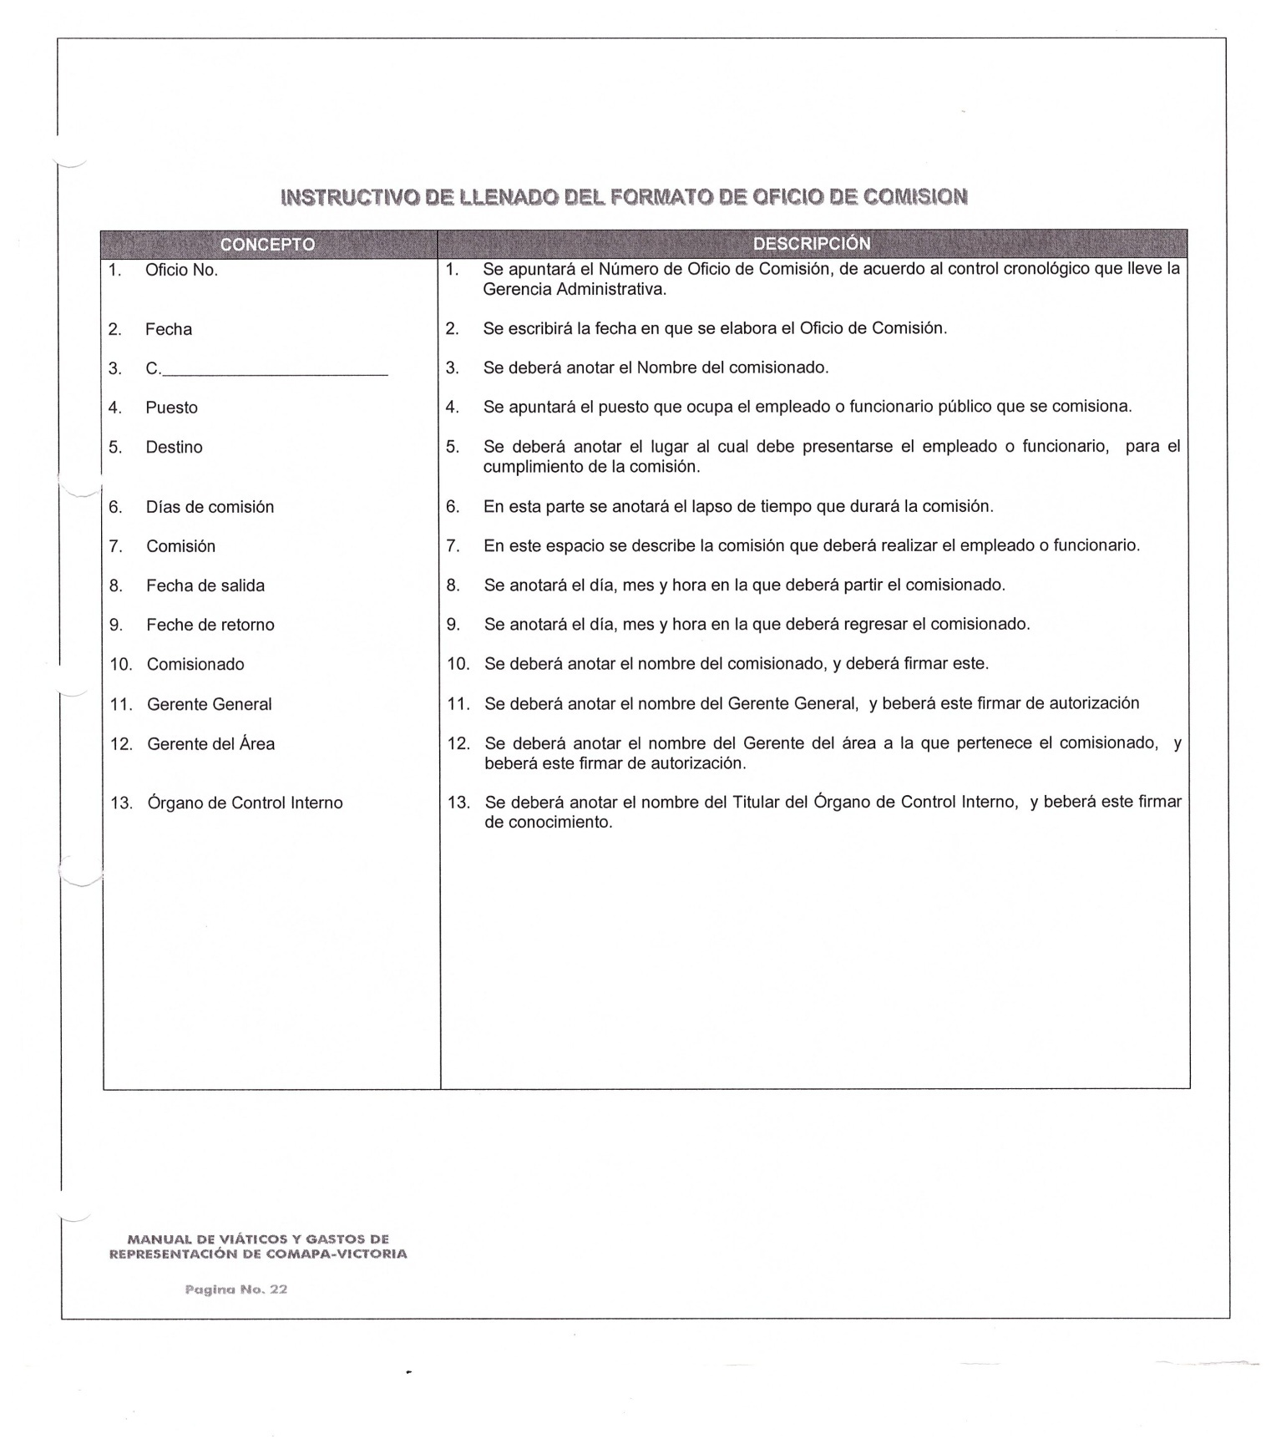

________________________ ________________________________ _____________________________
ING. ELISEO GARCIA LEAL C.P. SERGIO MARTINEZ VILLARREAL C.P. LAURA ARRIETA HERNANDEZ
GERENTE GENERAL GERENTE ADMINISTRATIVO CONTROL ESTADISTICO

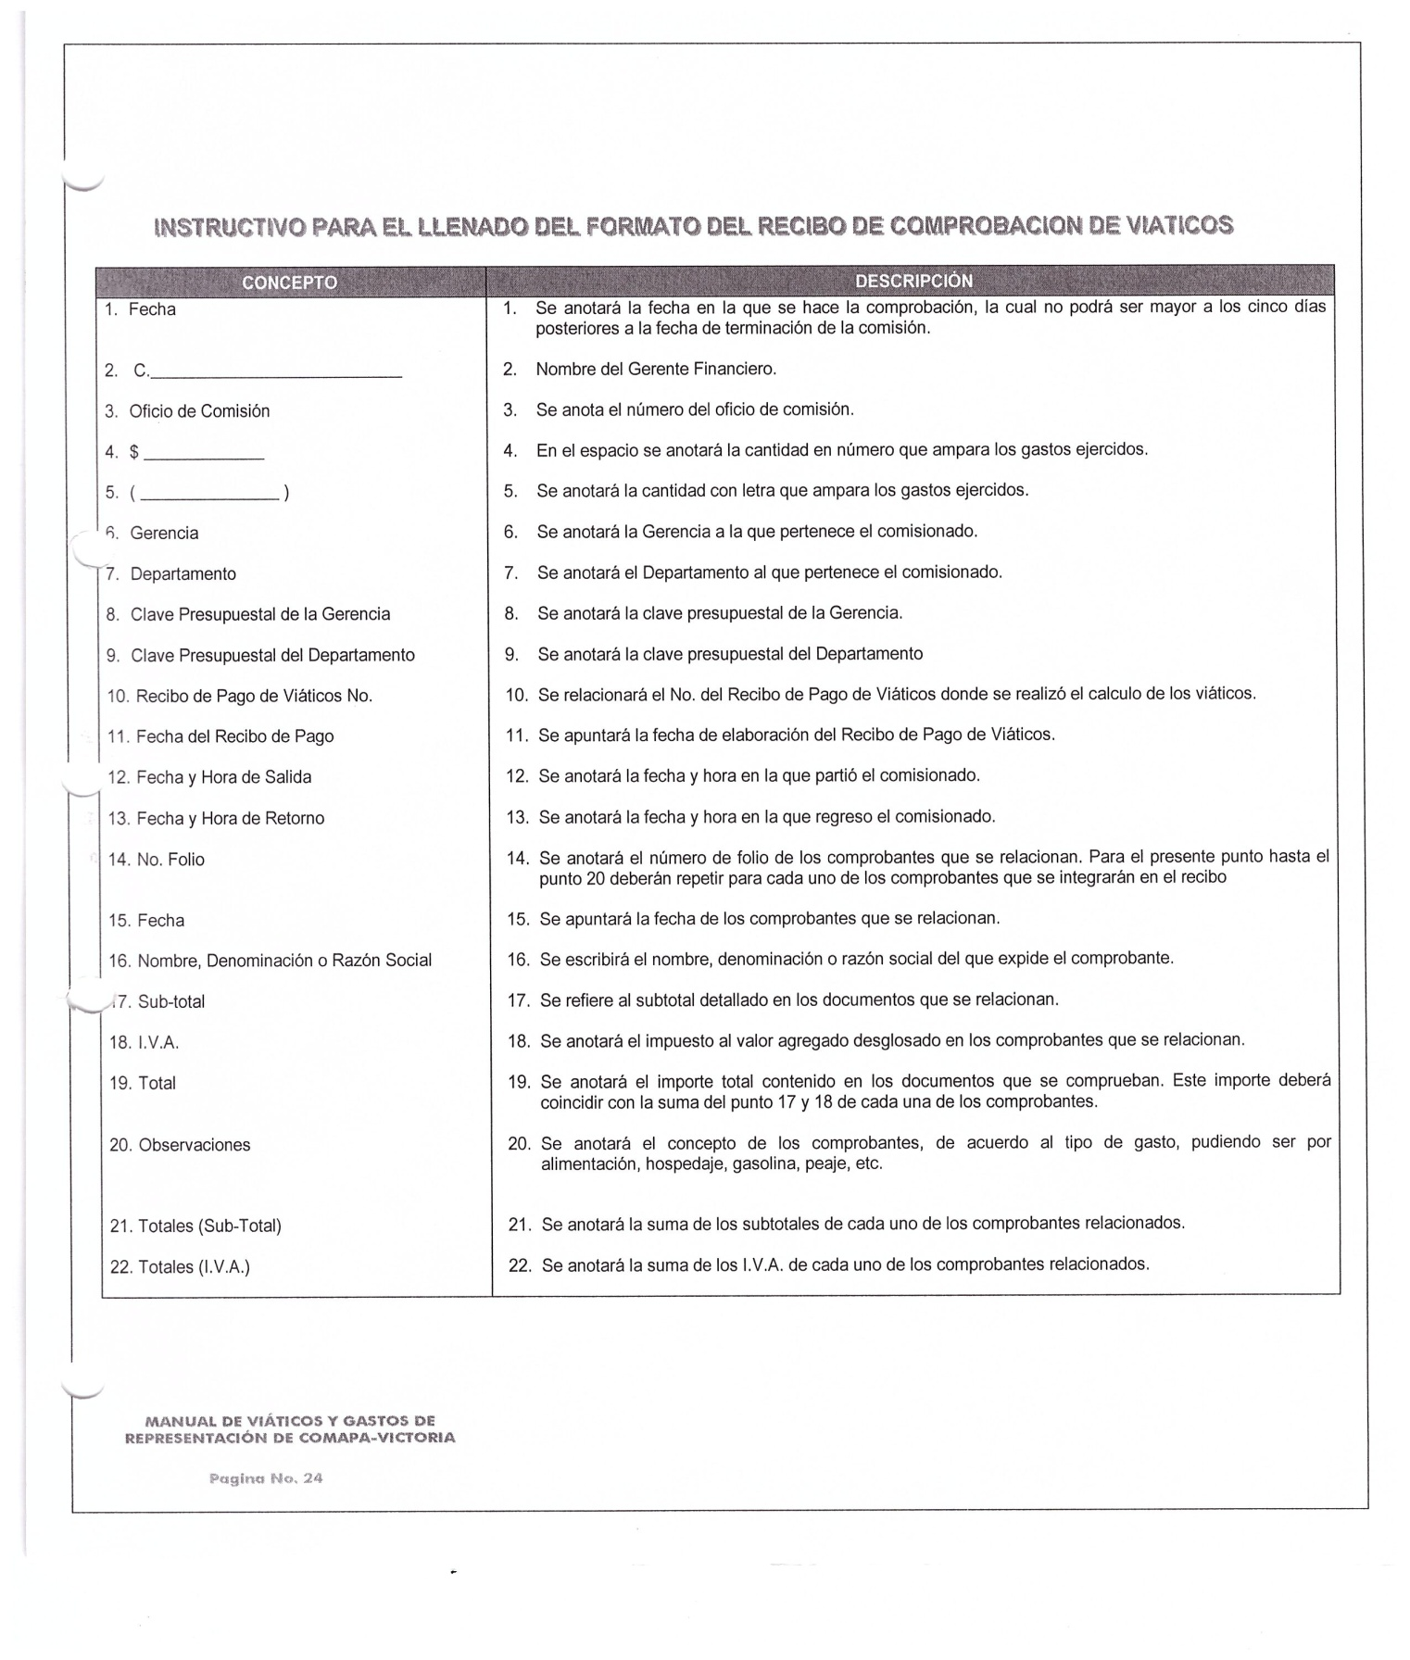

________________________ ________________________________ _____________________________
ING. ELISEO GARCIA LEAL C.P. SERGIO MARTINEZ VILLARREAL C.P. LAURA ARRIETA HERNANDEZ
GERENTE GENERAL GERENTE ADMINISTRATIVO CONTROL ESTADISTICO

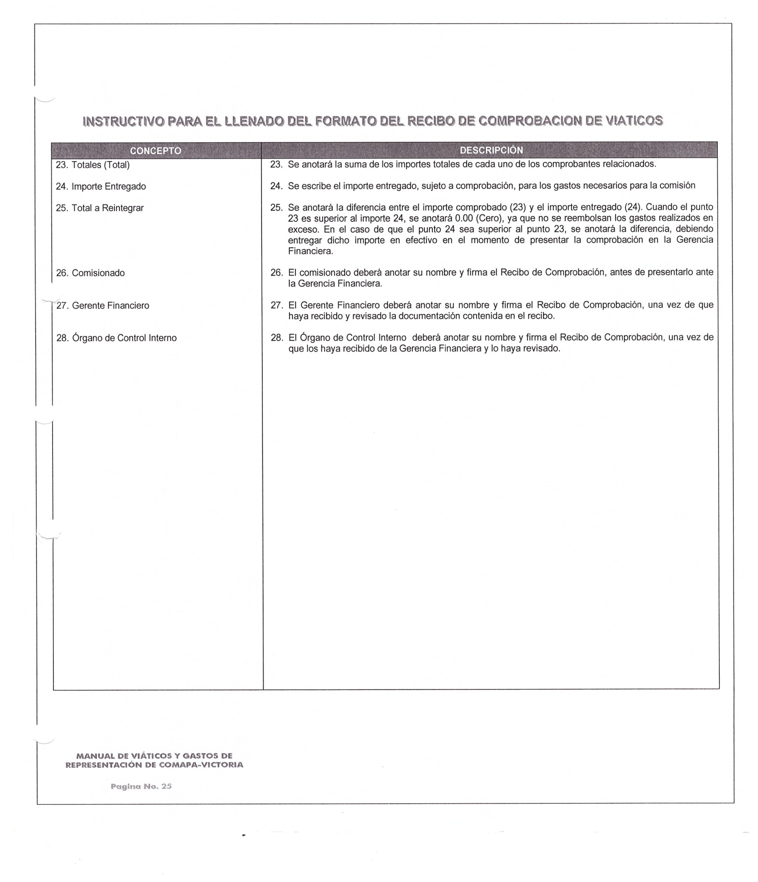

________________________ ________________________________ _____________________________
ING. ELISEO GARCIA LEAL C.P. SERGIO MARTINEZ VILLARREAL C.P. LAURA ARRIETA HERNANDEZ
GERENTE GENERAL GERENTE ADMINISTRATIVO CONTROL ESTADISTICO

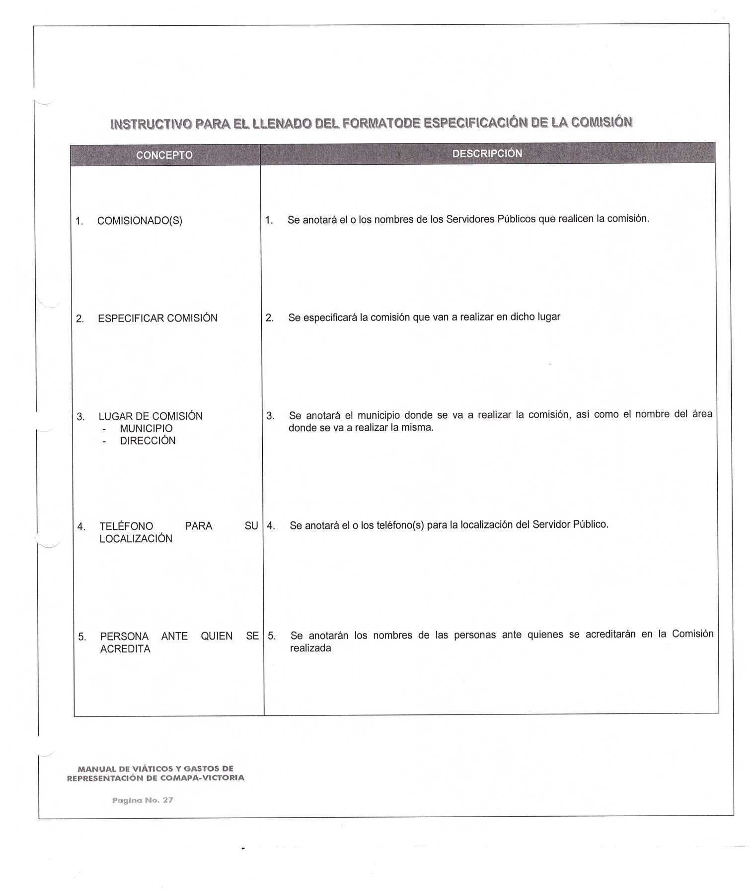

________________________ ________________________________ _____________________________
ING. ELISEO GARCIA LEAL C.P. SERGIO MARTINEZ VILLARREAL C.P. LAURA ARRIETA HERNANDEZ
GERENTE GENERAL GERENTE ADMINISTRATIVO CONTROL ESTADISTICO

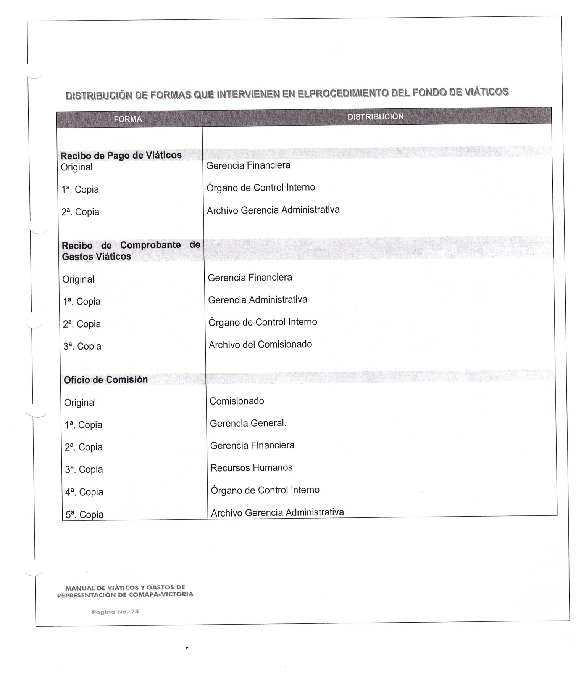
________________________ ________________________________ _____________________________
ING. ELISEO GARCIA LEAL C.P. SERGIO MARTINEZ VILLARREAL C.P. LAURA ARRIETA HERNANDEZ
GERENTE GENERAL GERENTE ADMINISTRATIVO CONTROL ESTADISTICO

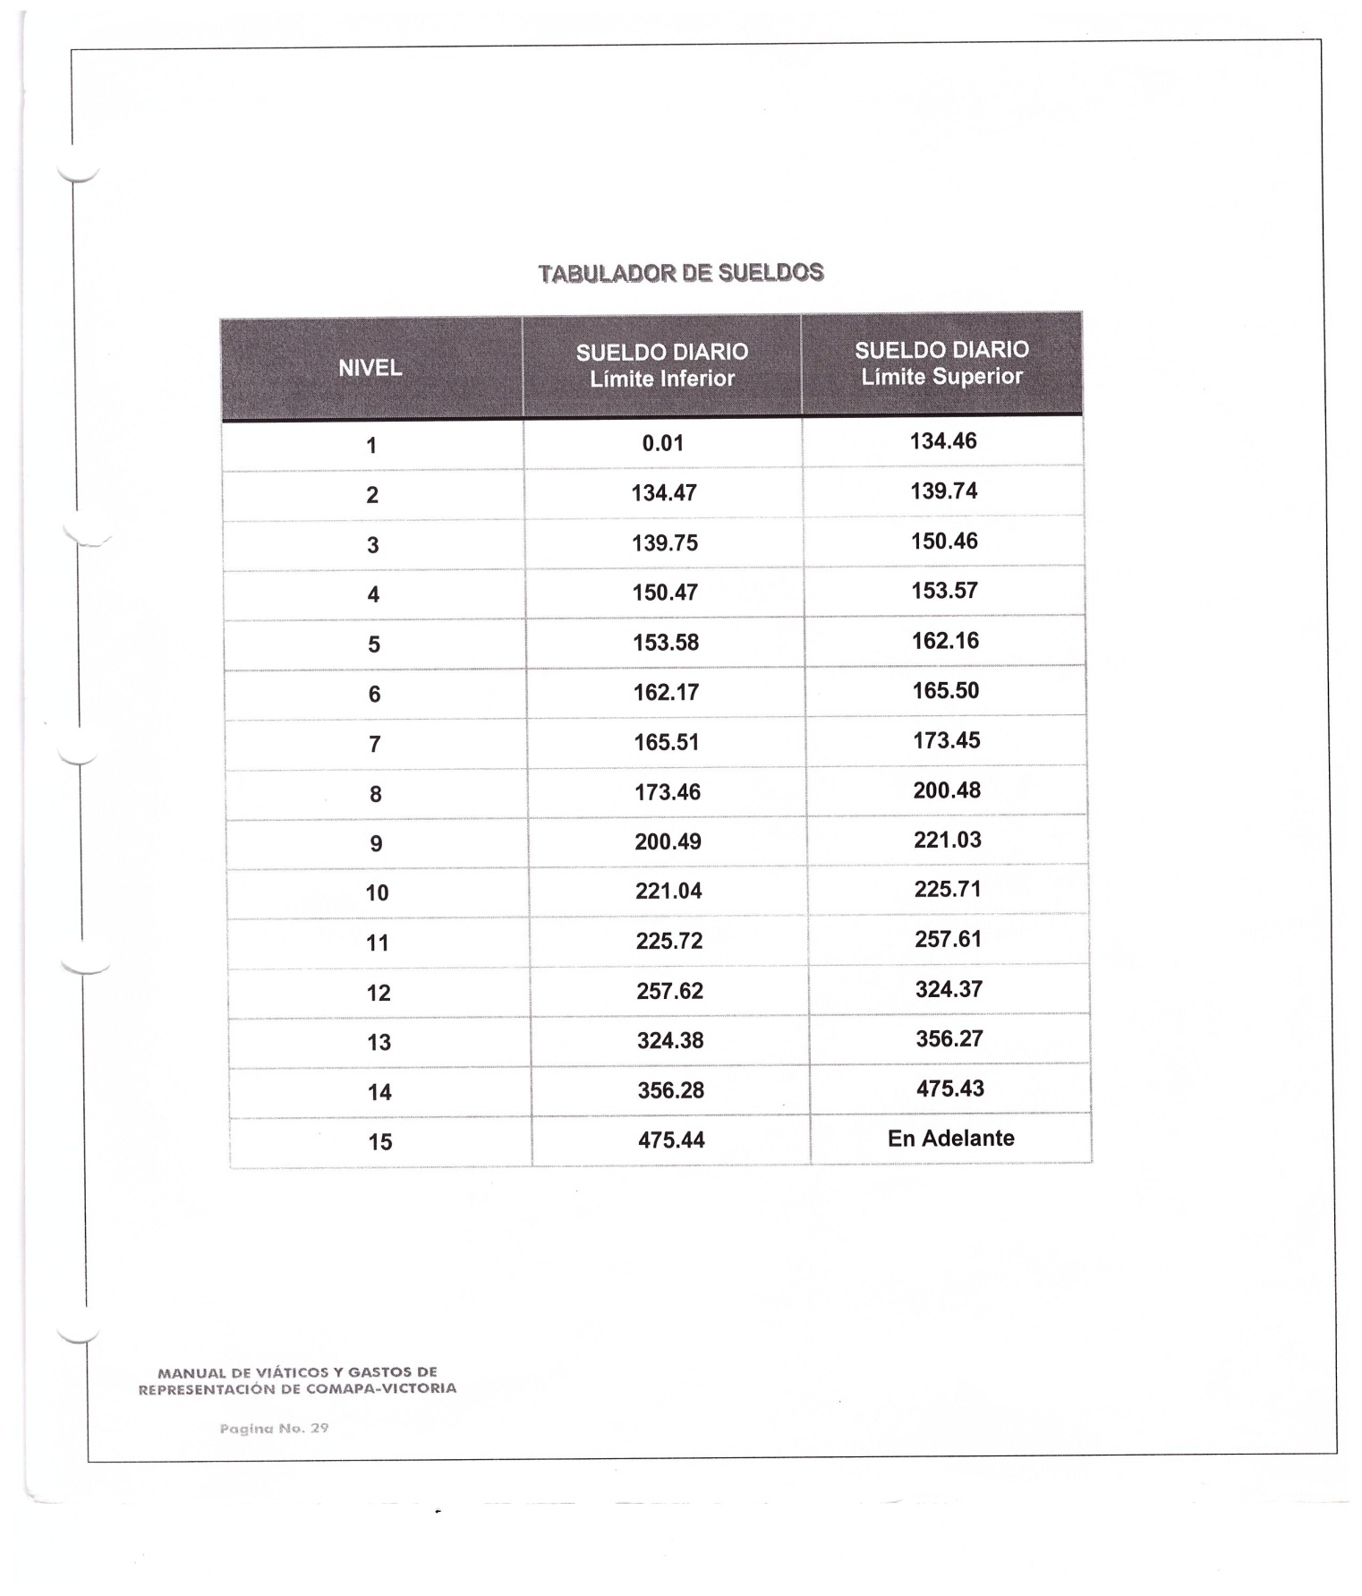

________________________ ________________________________ _____________________________
ING. ELISEO GARCIA LEAL C.P. SERGIO MARTINEZ VILLARREAL C.P. LAURA ARRIETA HERNANDEZ
GERENTE GENERAL GERENTE ADMINISTRATIVO CONTROL ESTADISTICO

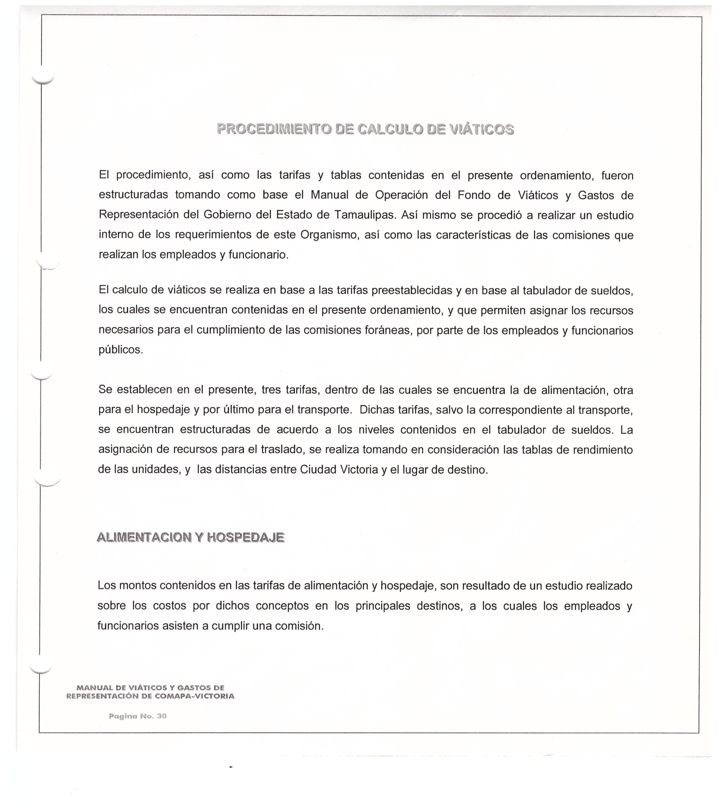

________________________ ________________________________ _____________________________
ING. ELISEO GARCIA LEAL C.P. SERGIO MARTINEZ VILLARREAL C.P. LAURA ARRIETA HERNANDEZ
GERENTE GENERAL GERENTE ADMINISTRATIVO CONTROL ESTADISTICO

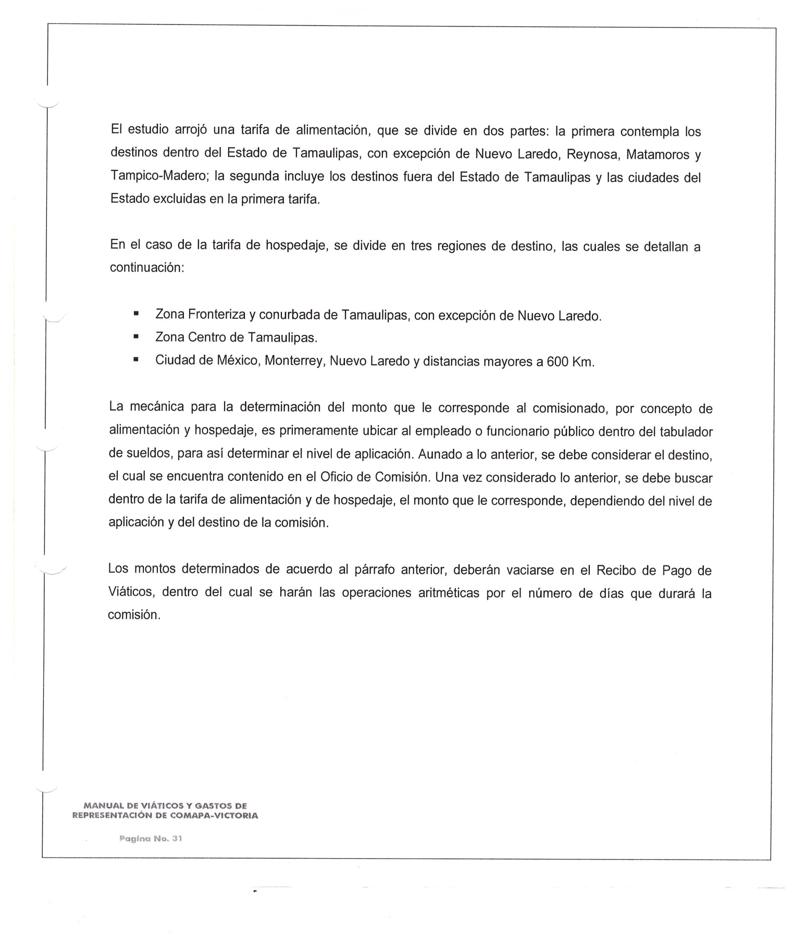
________________________ ________________________________ _____________________________
ING. ELISEO GARCIA LEAL C.P. SERGIO MARTINEZ VILLARREAL C.P. LAURA ARRIETA HERNANDEZ
GERENTE GENERAL GERENTE ADMINISTRATIVO CONTROL ESTADISTICO

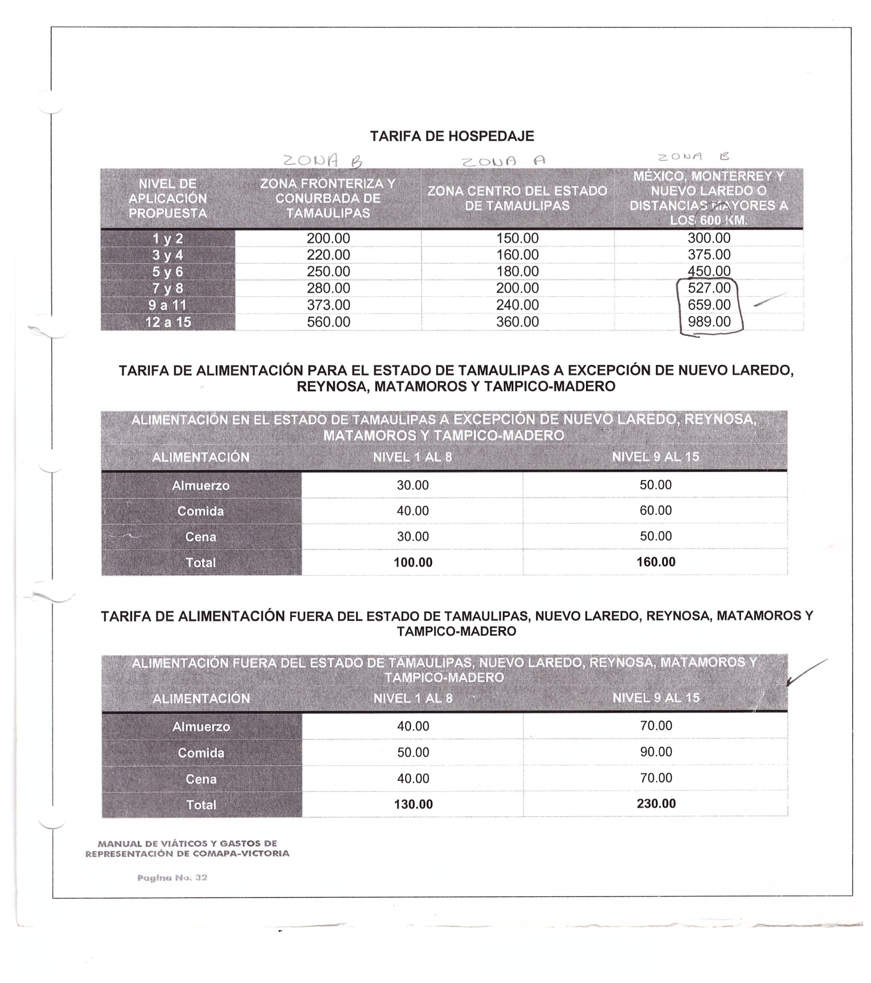

________________________ ________________________________ _____________________________
ING. ELISEO GARCIA LEAL C.P. SERGIO MARTINEZ VILLARREAL C.P. LAURA ARRIETA HERNANDEZ
GERENTE GENERAL GERENTE ADMINISTRATIVO CONTROL ESTADISTICO

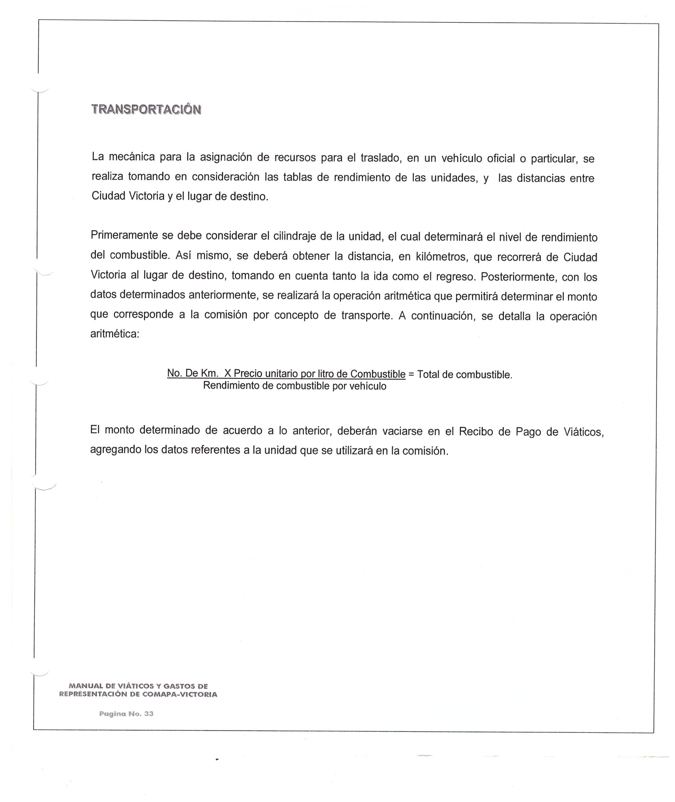

________________________ ________________________________ _____________________________
ING. ELISEO GARCIA LEAL C.P. SERGIO MARTINEZ VILLARREAL C.P. LAURA ARRIETA HERNANDEZ
GERENTE GENERAL GERENTE ADMINISTRATIVO CONTROL ESTADISTICO

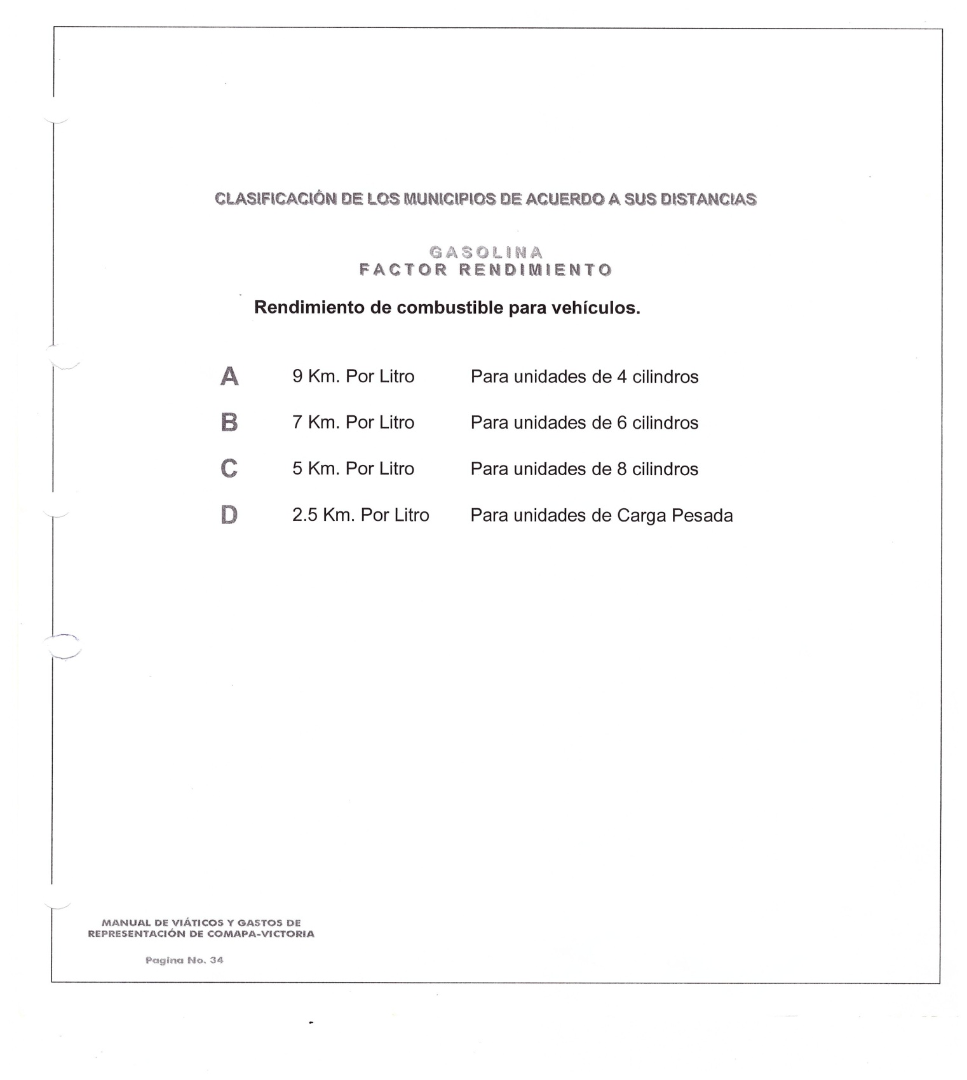

________________________ ________________________________ _____________________________
ING. ELISEO GARCIA LEAL C.P. SERGIO MARTINEZ VILLARREAL C.P. LAURA ARRIETA HERNANDEZ
GERENTE GENERAL GERENTE ADMINISTRATIVO CONTROL ESTADISTICO

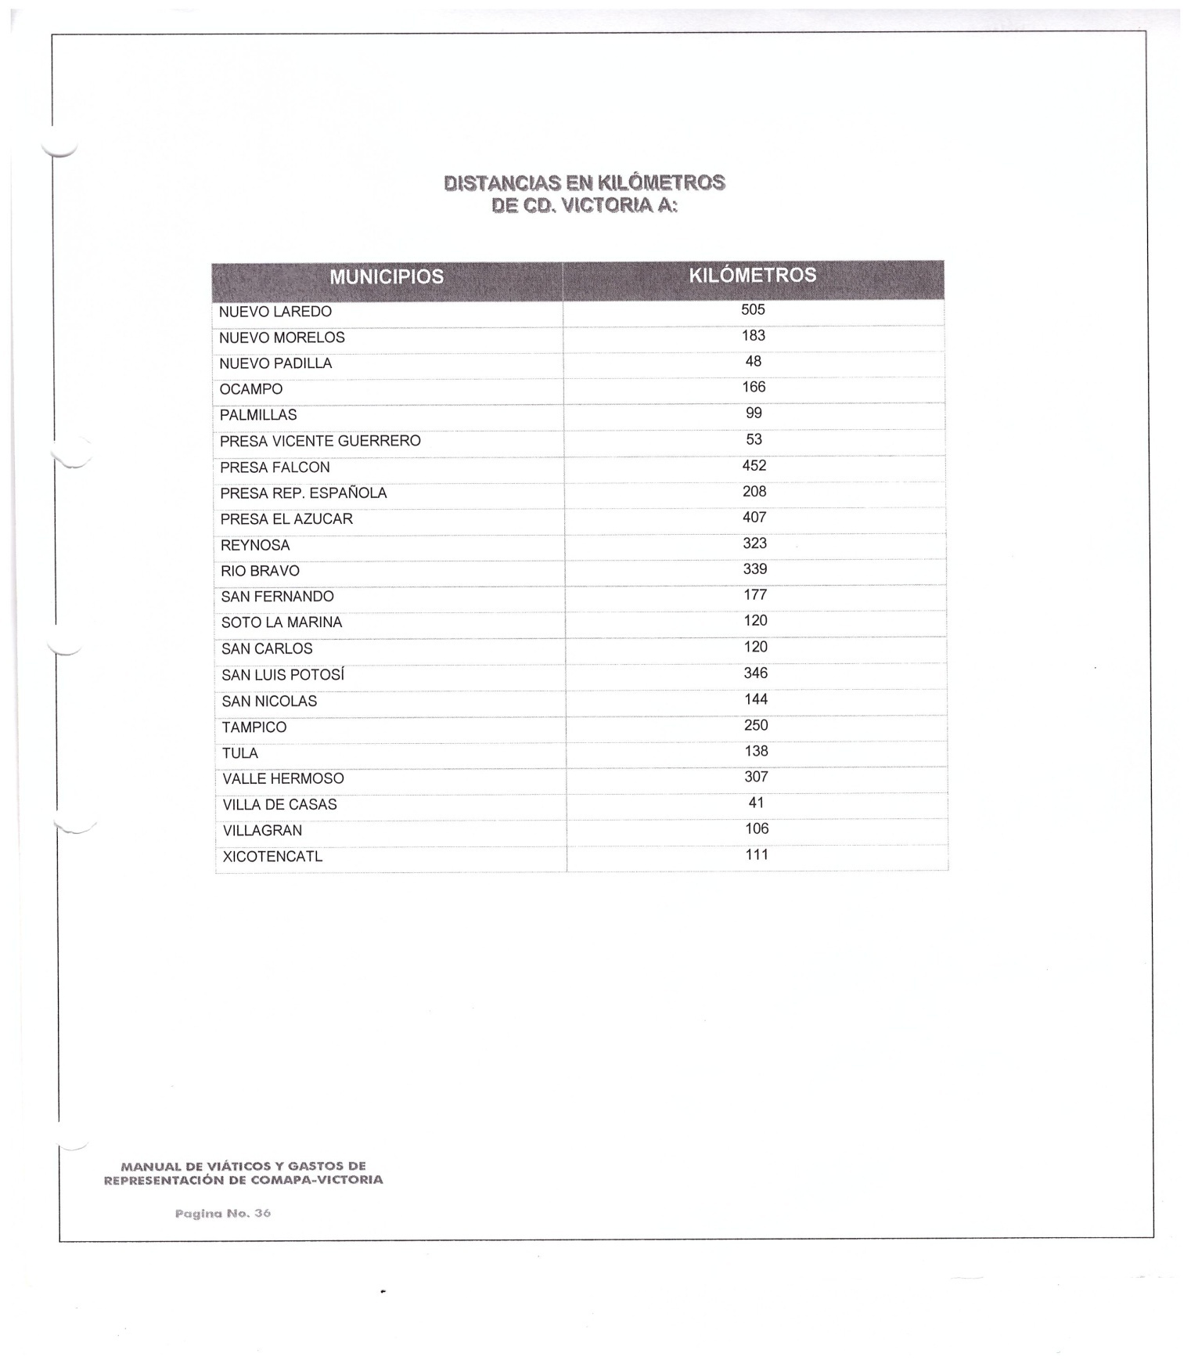

________________________ ________________________________ _____________________________
ING. ELISEO GARCIA LEAL C.P. SERGIO MARTINEZ VILLARREAL C.P. LAURA ARRIETA HERNANDEZ
GERENTE GENERAL GERENTE ADMINISTRATIVO CONTROL ESTADISTICO

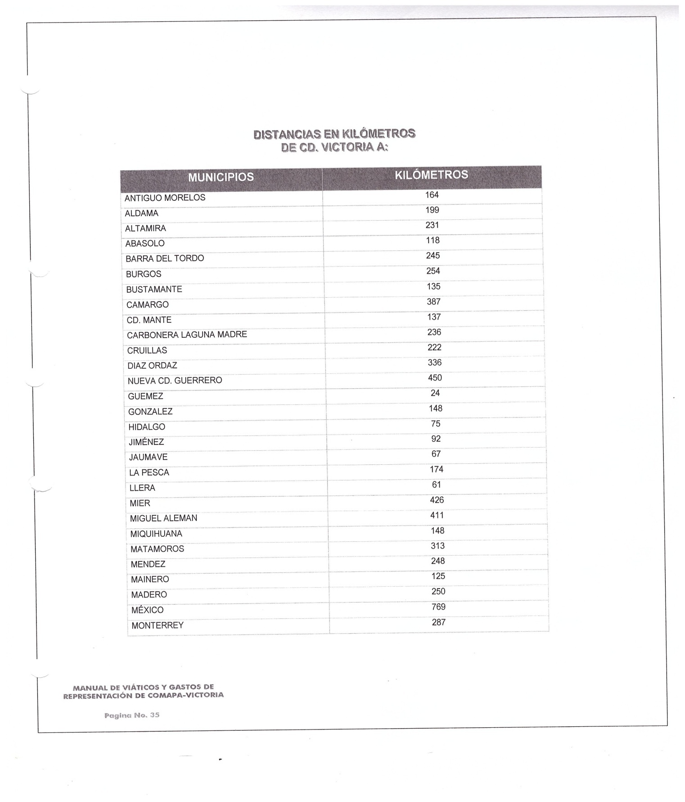

________________________ ________________________________ _____________________________
ING. ELISEO GARCIA LEAL C.P. SERGIO MARTINEZ VILLARREAL C.P. LAURA ARRIETA HERNANDEZ
GERENTE GENERAL GERENTE ADMINISTRATIVO CONTROL ESTADISTICO

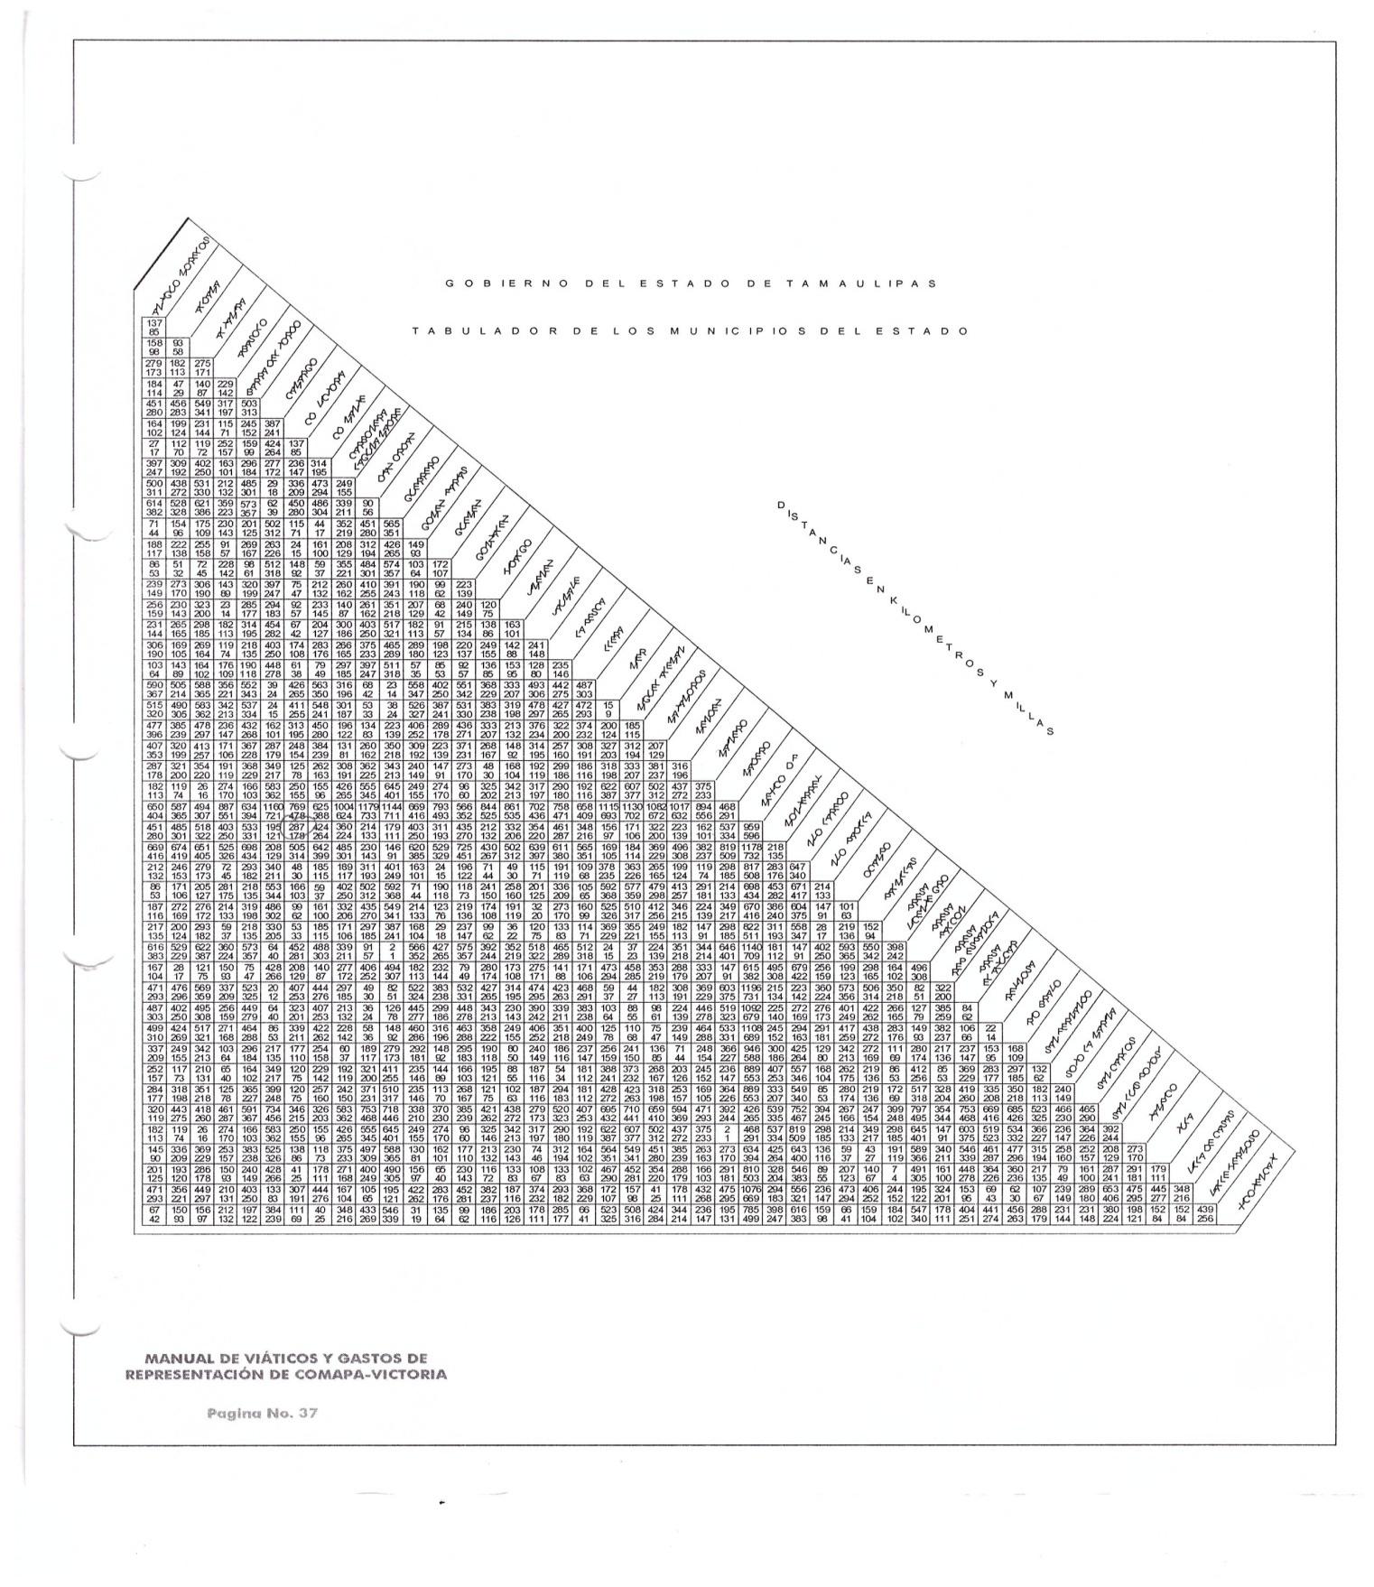

________________________ ________________________________ _____________________________
ING. ELISEO GARCIA LEAL C.P. SERGIO MARTINEZ VILLARREAL C.P. LAURA ARRIETA HERNANDEZ
GERENTE GENERAL GERENTE ADMINISTRATIVO CONTROL ESTADISTICO

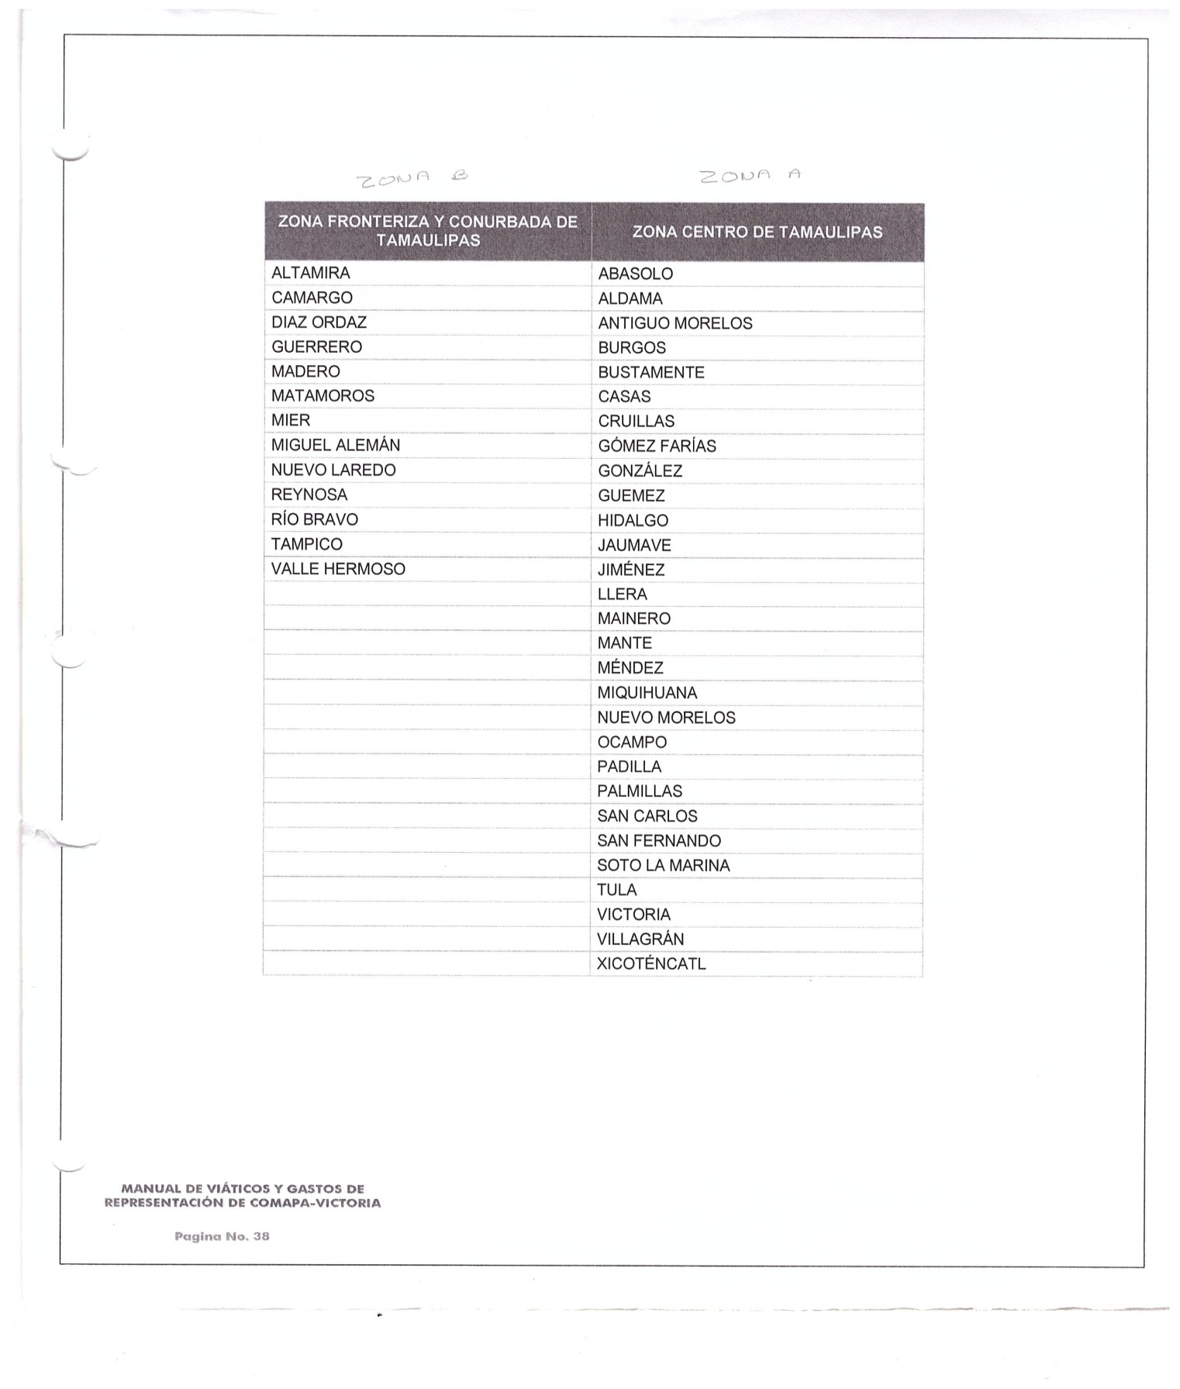

________________________ ________________________________ _____________________________
ING. ELISEO GARCIA LEAL C.P. SERGIO MARTINEZ VILLARREAL C.P. LAURA ARRIETA HERNANDEZ
GERENTE GENERAL GERENTE ADMINISTRATIVO CONTROL ESTADISTICO

